**IN 2900- Industry based project**

**Interim Report**

**Level 2**

**Web Based Knowledge Sharing System**

**by**

Aimers

|  |  |
| --- | --- |
| **Student Registration No** | **Student Name** |
| 154199T | MADHUSANKA E.R.H. |
| 154198N | MUNASINGHE L.T. |
| 154075K | PATHIRANA I.M.P. |
| 154090C | RAJAPAKSHA R.P.M.P. |
| 154107M | SAMARANAYAKE S.N. |

Faculty of Information Technology

University of Moratuwa

2017

**IN 2900-Industry based project**

**Interim Report**

**Level 2**

**Web Based knowledge sharing system**

**by**

Aimers

|  |  |  |  |
| --- | --- | --- | --- |
| **Student Registration No** | **Student Name** | **Signature** | **Date** |
| 154199T | MADHUSANKA E.R.H. | _ _ _ _ _ _ | _ _ _ _ _ _ |
| 154198N | MUNASINGHE L.T. | _ _ _ _ _ _ | _ _ _ _ _ _ |
| 154075K | PATHIRANA I.M.P. | _ _ _ _ _ _ | _ _ _ _ _ _ |
| 154090C | RAJAPAKSHA R.P.M.P. | _ _ _ _ _ _ | _ _ _ _ _ _ |
| 154107M | SAMARANAYAKE S.N. | _ _ _ _ _ _ | _ _ _ _ _ _ |

**Supervisor’s Name:** Mrs.K. A. Dilini T.Kulawansa

Senior Lecturer

Department of Computational Mathematics  
 Faculty of Information Technology  
 University of Moratuwa

**_ _ _ _ _ _ _ _ _ _ _ _ _**

**Date**

**Signature**

**Details of the Company:** Mr. Enhanzer (pvt) Ltd

05/E/1,Darmapala Mawatha,

Pannipitiya

Sri Lanka

[www.enhanzer.com](http://www.enhanzer.com)

011 208 8168

**Details of the Client:**  Mr. Amila Senadeera

Business Analyst

Enhanzer (Pvt) Ltd

[amila@enhanzer.com](mailto:amila@enhanzer.com)

0713068889

Faculty of Information Technology

University of Moratuwa

2017

**Abstract**

First of all, we did a preliminary research on similar approaches related to our topic. We could find some existing system similar to us like GitHub, Academis.edu, Moodle, Coursera and Facebook groups etc. By studying them, we got a clear idea about their characteristics as well as their drawbacks. Then we started to search available technologies and selected applicable technologies among them. After discussing with our client, we decided to use Asp.net, MS SQL, Bootstrap, Visual studio and android as main suitable technologies. To become familiar with these technologies we designed a sample event data recording system using html, JavaScript, CSS, JQuery, PHP and MYSQL. This sample system includes a registration module, event data record module, event delete module and display upcoming events module. Then we understood two main modules of the system as client side module and server side module. Admin, Unregistered user and user (Lecture and student) were understood next as actors related to our system. Then we studied about relationships within actors. Our next task was analyzing and designing the system. As the analysis stage we understood user requirements and how the system should function in order to provide an efficient service. According to that, we designed a top-level architecture of our proposed system. Then we created a module diagram dividing our modules in to backend and front end. Our next phase was designing system diagram. Then we searched available resources to draw UML diagrams. We could find Star UML and Draw.io online tool as easiest tools to design UML diagrams. Star UML was used to draw Activity diagrams, Sequence diagrams, Class diagram, Use Case diagram. EER diagram and Context diagram were designed using Draw.io online tool. We drew flow charts for each process to indicate the flow of activities. As an evaluation method, we designed feedback forms. To improve the efficiency, we created separate feedback forms for each user as for undergraduates, non- undergraduates and for school students.

**Table of Contents**

Page

|  |  |
| --- | --- |
| 1. Introduction to web based knowledge sharing system |  |
| 1.1 Introduction | 01 |
| 1.2 Problem in brief | 02 |
| 1.3 Background and Motivation | 03 |
| 1.4 Aim and Objectives |  |
| 1.4.1 Aim | 04 |
| 1.4.2 Objectives | 04 |
| 1.5 Summary | 05 |
|  |  |
| 2. Current issues in Web Based Knowledge Sharing Systems |  |
| 2.1 Introduction | 06 |
| 2.2 Similar approaches |  |
| 2.2.1 GitHub | 07 |
| 2.2.2 Academia.edu | 07 |
| 2.2.3 Moodle | 08 |
| 2.2.4 Coursera | 09 |
| 2.2.5 W3 schools | 09 |
| 2.2.6 Facebook Groups | 10 |
| 2.3 Summary | 11 |
| 3. Suitability of the chosen technologies |  |
| 3.1 Introduction | 13 |
| 3.2 Technologies |  |
| 3.2.1 Asp.net | 13 |
| 3.2.2 MS SQL | 14 |
| 3.2.3 Visual studio | 14 |
| 3.2.4 Android studio | 15 |
| 3.2.5 Bootstrap | 16 |
| 3.3 Summary | 16 |
| 4. Our Approach to web based knowledge sharing system |  |
| 4.1 Introduction | 18 |
| 4.2 Usage of technologies |  |
| 4.2.1 Modular Approach | 18 |
| 4.2.1.1 Developing the client side module | 19 |
| 4.2.1.2 Developing the server side module | 19 |
| 4.2.2 Actors of the System | 19 |
| 4.2.3 Actors and modules and their relationships |  |
| 4.2.3.1 User Validation Module | 20 |
| 4.2.3.2 Discussion Module | 20 |
| 4.2.3.3 File Sharing Module | 21 |
| 4.2.3.4 Event Organizing Module | 21 |
| 4.3 Summary | 22 |
| 5. Analysis and Design |  |
| 5.1 Introduction | 23 |
| 5.2 System Analysis | 24 |
| 5.3 Module Design |  |
| 5.3.1 Interface module of admin | 25 |
| 5.3.2 Interface module of user | 26 |
| 5.3.3 The Server | 26 |
| 5.3.4 Database | 26 |
| 5.4 System diagrams |  |
| 5.4.1 Context Diagram | 27 |
| 5.4.2 Use case Diagram | 29 |
| 5.4.3 Activity Diagram | 30 |
| 5.4.4 Sequence diagram | 34 |
| 5.4.5 Class Diagram | 38 |
| 5.4.6 EER Diagram | 39 |
| 5.5 Summary | 40 |
| 6. Implementation |  |
| 6.1 Introduction | 41 |
| 6.2 Implementation |  |
| 6.2.1 Register to the system | 42 |
| 6.2.2 Login to the system | 43 |
| 6.2.3 Create/Join group | 44 |
| 6.2.4 Upload a file | 45 |
| 6.2.5 Event Organizing | 46 |
| 6.3 Summary | 47 |
| 7. Evaluation Progress |  |
| 7.1 Introduction | 48 |
| 7.2 Design of the Questionnaire | 48 |
| 7.3 User Feedback Analysis | 52 |
| 7.4 Summary | 52 |
| 8. Discussion |  |
| 8.1 Introduction | 53 |
| 8.2 Achievement of objectives | 53 |
| 8.3 Problems encountered | 54 |
| 8.4 Limitations of our proposed solution | 54 |
| 8.5 Future work | 54 |
| 8.6 Summary    Reference  Appendix A - Individual contribution to the project  Appendix B - Source codes | 55    56  56  61 |

**List of figures**

Page

|  |  |  |
| --- | --- | --- |
| Figure 5.1 - Top level architecture of the proposed system |  | 24 |
| Figure 5.2 - Module Diagram of the system |  | 26 |
| Figure 5.3 - Level 0 Context diagram |  | 27 |
| Figure 5.4 - Level 1 Context diagram |  | 28 |
| Figure 5.5 - Use Case diagram |  | 29 |
| Figure 5.6 - Activity diagram of login process |  | 30 |
| Figure 5.7 - Activity diagram of group handling process |  | 31 |
| Figure 5.8 - Activity diagram of file uploading process |  | 32 |
| Figure 5.9 - Activity diagram of event organizing process |  | 33 |
| Figure 5.10 - Sequence diagram of login process |  | 34 |
| Figure 5.11 - Sequence diagram of group handling process |  | 35 |
| Figure 5.12 - Sequence diagram of file uploading process |  | 36 |
| Figure 5.13 - Sequence diagram of event organizing process |  | 37 |
| Figure 5.14 - Class diagram |  | 38 |
| Figure 5.15 - EER diagram |  | 39 |
| Figure 6.1 - Flow chart of registration process |  | 42 |
| Figure 6.2 - Flow chart of login process |  | 43 |
| Figure 6.3 - Flow chart of create /join group |  | 44 |
| Figure 6.4 - Flow chart of File upload process |  | 45 |
| Figure 6.5 - Flow chart of event organizing process |  | 46 |
|  |  |  |

**List of tables**

|  |  |
| --- | --- |
| Table 2.1 - Comparison between existing Software Systems | 11 |
| Table 4.1 - Summary of Our Approaches | 22 |
| Table 7.1 - Feedback form for Undergraduates | 49 |
| Table 7.2 - Feedback form for Non-Undergraduates | 50 |
| Table 7.3 - Feedback form for School Students | 51 |

Page

**Chapter 1**

**Introduction to Web based Knowledge Sharing Systems**

* 1. **Introduction**

Nowadays People have understood the value of learning and education. They try to raise their knowledge in many ways and we know Knowledge is both social and individual. Educational psychologists have identified that when students work together in collaborative teams, they learn material better than when they study alone [31]. Community based education is a method to promote learning and social development work with individuals and groups. It helps to share knowledge and experience through communication. So that each individual can operate more effectively and can express their ideas freely.

Community based learning provides easy way of discussing and communicating with other people, easy way of accessing shared data, exchanging learnt knowledge and learning materials with others [30]. Main advantage of community based learning is that this process expends the word “intelligent”. Because the learner can acquire understanding, use knowledge, and find solution for their problems, while evolving a sense of self.

Success or witness in not only based on learning core academic subjects, but the improvement of both academic and extracurricular activities and as well as building relationships and interpersonal development [31]

When we consider sharing knowledge, it depends on the habits, willingness, and commitments of the knowledge worker to find out and be receptive to these knowledge sources. It is all about linking people, ideas and organizations to enable information exchange and networking activities. By exchanging stories, problems and solutions this method can bring their collective knowledge to bear on individual problems. We came up with this idea by seeing lot of issues around us. Such as there are thousands of students who cannot find the most appropriate and most suitable method or guidance for their learning.

By thinking all of these problems, we thought to build up this solution by creating an application by connecting all universities, students and lecturers/teachers in one place. So here we are implementing and designing application which will be useful to everyone in upcoming days.

Through this concept we can develop Sharing and co-Learning about related practices across projects, learning while doing, Professional development, organizing events, share expertise knowledge among others, organize activities for volunteers, Interconnection with different Universities/Institutes etc.

**1.2 Problem in Brief**

Knowledge sharing is an activity which knowledge (namely, information, skills or expertise) is exchanged among people, communities or organizations and that is a very important activity. But currently there are only very few knowledge sharing methods, which can pass on or receive information to and from others.

We know that every student cannot get higher education from government universities and also every other cannot afford such a huge fee to follow a private course. If we take an existing web based study group, the participation of professionals like lecturers also very less.

In addition, there are so many people searching for new technologies and knowledge, which fulfill their needs and solve current issues. The technological barriers such as lack of integration of IT systems, lack of technical support (internal and external) and immediate maintenance of integrated IT systems, unrealistic expectations of people as to what technology can do and cannot do , lack of compatibility between diverse IT systems and processes and mismatch between individuals’ need requirements and integrated IT systems restrict the sharing knowledge among others[30].Therefore some creative ideas are dispersed due above discussed barriers and some good innovations are wasted without any usage.

Because of the less facilities and weak communication, the knowledge sharing between long distance people has become very poor. For an example the connection and the cooperation between all the universities in Sri Lanka is very low. We do not have a proper method to inform others regarding the events we organized.

The purpose of our project is to avoid above issues by creating a highly focused environment that encourages team work, collaboration, the sharing of knowledge and continuous learning

**1.3 Background and Motivation**

There are thousand number of students’ study on their interesting fields in their universities throughout the world. But the inter connection between students who are studying in same field is very less.

Also there are lot of students who were not selected to their preferred courses at universities. They may interest to aware and share the knowledge with internal students and professionals who are working on relevant field. In other hand, there are some professors are expertise for some specific fields. But their service is very limited for one university or two. Though they are pleasure to share their knowledge, they have no facilities and have more barriers to do that.

So we hope to introduce a new website to make an inter connection between internal students, professors and other interesting people. This website has all details about them and their upcoming events. So interesting people can use our website to contact professors and students. All the details are updated. E-learning is defined as teaching and learning technique with use of electronic media that enhance learners’ autonomy. It is obvious to see that web-based instruction and e-learning have played a vital role in teaching and learning at any levels. There is web online to allow architects to design their plans. Using it architects can design a particular plan online and get an output.

But they do not give any way to contact clients. But in our system we provide online message system for the communication between customer and architect

E-learning, one of the tools emerged from information technology, has been integrated in many universities education programs, but in Sri Lanka there is no any system to inter connect with each other universities. Our system is an e-learning system which is having a clear interconnection with other government universities and private universities.

**1.4 Aim and Objectives**

**1.4.1 Aim**

The aim of our industry based project is to develop a responsive, specified and dynamic web application and a mobile application making a direct connection between knowledge seekers with the use of technologies like JSON, JQUERY, CSS, SQL, PHP, Python, Angular JS and Java

**1.4.2 Objectives**

In order to achieve the above-mentioned aim the following objectives have defined:

* Study the behavior of knowledge seekers
* Study of new technologies like JSON
* Create a database which consist necessary details about all entities
* Design a responsive and dynamic web application
* Design a community area in the webpage
* Develop an interactive system for all the users
* Create an Android app to attract more people
* Create an online quiz system
* Create a Desktop application
* Evaluation of the proposed solution
* User feedback analysis
* Preparation of final documentation

**1.5 Summary**

In chapter 1 we have given a brief introduction to a web based knowledge sharing system under sub headings like problem in brief, Background and motivation and Aim and Objectives. Chapter 2 describes the similar approaches that are already existing in this field and highlights the extra ordinary features that we are going to include in our final product. Chapter 3 explains the technologies that will be used in order to implement our system. Chapter 4 provides a description with reference to users, inputs, outputs, and the process with expected technologies. Chapter 5 is about analysis and design and this chapter include a diagram which describes the overall design and the top level architecture of the proposed system. Here we describe each module with its functionalities and we show the interaction between each module/component. Chapter 6 describes the implementation of each module which described in chapter 5. To show the implementation of each module we use flowcharts, algorithms, source codes, screenshots etc. Chapter 7 is dedicated for the discussion where we compare our system against other similar approaches. Also we discuss how we have planned to conduct the user feedback analysis by using a questionnaire.

**Chapter 2**

**Current issues in Web Based Knowledge Sharing Systems**

**2.1** **Introduction**

In first chapter we stated a clear idea about what we are going to implement in this project and the background and motivation. Hopefully it has been able to provide the necessity of a well-developed web based knowledge sharing system. In this chapter we focus on other works and existing systems which people have already implemented. This second chapter gives a comparison between existing systems with our system by highlighting the specific features that we are going to include in our final product.

**2.2** **Similar approaches**

Before developing our own system, we decided to do a research about similar approaches. We were able to identify some of the software systems that have already been developed as web based knowledge sharing systems. There is no such product like ours which provides almost all the services in one software application. Therefore, we decided to deeply go through the details of other web based knowledge sharing systems that have been already implemented and currently being used in order to identify their both strengths and weaknesses. We believe that these identified factors will be very useful to implement a better product. The existing systems that we found are listed as follows,

* GitHub
* Academia.edu
* Moodle
* Coursera
* W3 schools
* Facebook Groups

**2.2.1 GitHub**

GitHub is a web based version control system and an Internet hosting service which was introduced on 18th February 2008 by Tom Preston-Werner together with Chris Wansstrath and PJ Heylt. Headquarters is situated in San Francisco, California. This system is used in software industry. Around 26 million users currently use GitHub for their open source coding projects. Ruby was the main technology used to develop this system.

GitHub is the worlds’ largest host of source codes. GitHub allows user to upload codes and share them by creating a repository [12]. Other users can use these codes for their projects after doing modifications of their own. Users can fix bugs after replying to the comments of members in the repository. GitHub provides a command line tool which help programmers to evaluate their code.

Using GitHub We can upload research papers and do project management.

But GitHub’s codes are not always easy to understand and its maintenance task takes time. Command line tools used in GitHub is complicated. Users can create groups but chatting with group members is not allowed in GitHub. Inability of managing events and not using the google map technology to show the event hosting place are some major weaknesses of GitHub. Most of the users are unsatisfied because of the high restrictions.

**2.2.2 Academia.edu**

Richard Price launched academia.edu in 2008 September. They were initially invested $600,000. Now Academia.edu have more than 31 million registered users. English language is the main available language. Users can register free of charge.

That is a networking website which was implemented for the academic purposes. We can use this system to share papers, and follow researches in a specific field. This web site allows users to create their own profile, upload their work(s), and select preferred areas. Then user can browse the networks of people with similar interests among almost all users from around the world [17]. But academia is not an institutional system and it is not a subject-based one. Academia. Academia.edu is an effective system for post publication views. Major disadvantages of academia.edu are users have to pay a fee to get their papers recommended by the websites’ editors [3]. This system is not having a legal right or legal responsibility about research and user uploaded papers or materials and also it is not supporting event management, not allowing making groups and chatting. One of the main issue in this site is that, it is very difficult to get/ obtain information that we need.

**2.2.3**  **Moodle**

Moodle was developed by Martin Dougiamas by using PHP in cross-platform. Version 1.0.9 was released in 30 May 2003. Stable version (3.3.0) was released in 15 May 2017. Their work and educational based activities and more other works are operating on through their website [moodle.org](https://moodle.org/). Moodle is available in more than 100 languages. Moodle is an open source software so we can access that free of charge. Moodle is not funded by ventures or any mentors and there is no any investors. Their main target was to render a service for the community, and they are not selling viewer’s ideas, investors are not seeking for any revenue or investment.

Moodle is used by lot people in all over the world. That system is used by various kind of institutes. This is for educators/learners who like to develop, manage, learn course online and that system is based on plugins and its available different kind of contents for that plugins [14].

Ex: plugging for Workshop manages the full process that can grade many of students accurately/efficiently for any assignment. This reduces the time consumption. We can add some reports, more plugins from community and also can write our own ideas. So it’s able to create an amazing, user friendly educational environment.

There are some drawbacks of Moodle. Moodle is limited for specific users/institute. So that it has lack of information, lower knowledge area. It is not allowed for any person in the world. On the other hand, we cannot create events and organize events etc.

**2.2.4 Coursera**

Coursera is a platform that gives the e-learning experience to the user, which was launched in April 2012 by Andrew NG together with Daphne Koller. Headquarters of coursera is located in Mountain view, California. Coursera is an online education site which currently owns 24 million registered users for their more than 2000 courses. Corsera works with universities, institutes as well as the government.

Every course on coursera is done by lecturers and each course include a recorded video, community discussion forums and auto graded and member reviewed assignments [18]. It provides an identity verification mechanism to maintain the security. The web based photo ID verification and the typing pattern is quite strong in courser.

Drawbacks courser are that it is not completely free and the quizzes are too lenient. It limits the number of users who are going to register on courser. Coursera does not support event management and it does not allow users to upload their own files/ research papers and project details. It does not support in making groups and chatting with group members

**2.2.5 W3 schools**

Norwegian software Development Company found W3 schools in 1998 as a free e-learning website for web development languages like PHP, JavaScript, HTML, Query, and Bootstrap etc. This is the worlds’ largest website for learning web development languages.

Students can select their preferred choices among various web development languages. [27]. There are variety of online tutorials that students can participate. Each student can take tests and quizzes to complete a particular course. Students can take a final test to prove their mastery and if they pay an extra fee to receive a certificate of completion.

But in W3 schools we cannot upload our files/ research papers or project documentations and also it does not support any event organizing methods. We cannot make groups and chat with peers for sharing knowledge using W3 schools

**2.2.6 Facebook Groups**

Facebook is a most popular social networking site that was launched in February 2004 April 04. Founder of the FB is Mark Zukerberg and his crew Andrew McCollum, Chris Hughes, Dustin Moskovits and Eduardo Sarverin. There are apporoximately 1.94 billion monthly active users.

First and foremost, user must register before using the site, after creating their own personal profile it allows to add users as friends, and send/receive messages. Automatically notifications will show when they upload their profile. Additionally, users can join user groups, organized by educational workplaces such as school/ university or other characteristics [29]. User can categorize their friends into various categories. Users can upload their own files/ research papers and project details through the Facebook page. Facebook supports event organizing also. Users can create an event and give publicity to their event using Facebook.

But main disadvantage in Facebook is that they do not use a proper verification process. Any user can create new accounts using their telephone number or email address. Because of that there are lot of fake accounts which provide wrong details and mislead people. Facebook is not only for educational facts. Facebook is mainly focused on entertainment, social activities etc.

**2.3** **Summary**

In the research of finding, the similar approaches related to our Web Based knowledge sharing Systems we came up with some other software, which have the similar features, and some different features compared to ours. Some systems, which we have been identified, are in good standard but have failed to provide all user requirements in a better way.

We could understand that there are some common factors, which we can show as weaknesses of these existing systems. They are

* Not involved in event organizing
* Less use of Google maps
* Inability to create groups and discuss problems with peers
* Inability to upload our own files/ research papers
* Not focused on project development

By identifying weaknesses and the drawbacks of the existing web based knowledge sharing systems, we have summarized the features that should be included in a well- developed web based knowledge sharing systems

Table 2.1 Comparison between existing Software System

|  |  |  |  |  |  |  |
| --- | --- | --- | --- | --- | --- | --- |
| Similar  applications |  |  |  |  |  |  |
|  | GitHub | Academia.edu | Moodle | Coursera | W3 Schools | Facebook  Groups |
| Characteristics |  |  |  |  |  |  |
|  |  |  |  |  |  |  |
| 1 | √ | √ | × | √ | × | √ |
|  |  |  |  |  |  |  |
| 2 | √ | × | √ | √ | × | × |
|  |  |  |  |  |  |  |
| 3 | × | × | √ | × | × | √ |
|  |  |  |  |  |  |  |
| 4 | √ | × | √ | × | √ | √ |
|  |  |  |  |  |  |  |
| 5 | √ | √ | √ | √ | × | √ |
|  |  |  |  |  |  |  |
| 6 | × | × | × | × | × | × |
|  |  |  |  |  |  |  |
| 7 | × | × | × | × | × | × |
|  |  |  |  |  |  |  |

**Characteristics**

1 – Creating Groups

2 – Sharing project/research report

3 – Organizing events

4 – Supplying all resources free

5 –Serial communication with group members

6– Dashboard with google map

7– Verifying account by NIC or university Identity card

This comparison table shows that none of the existing approaches having all the characteristics listed in the first column. Therefore, we decided to develop our own system including all the given characteristics

**Chapter 3**

# **Suitability of the Chosen Technologies**

**3.1** **Introduction**

In the previous chapter we discussed the similar approaches to our system software. In this chapter 3 we focus on giving a description and a brief idea about the suitability of the chosen technologies in solving the discussed problem. Here we describe what technologies that we are going to use in order to implement our application. We have planned to use technologies such as ASP.net framework with C# programming language, Java, MSSQL, Visual Studio and Android Studio, Bootstrap.

In this chapter we have included the reasons for choosing the above mentioned technologies among the number of available technologies.

**3.2 Technologies Adapted**

## 

## **3.2.1 Asp.net framework**

Asp.net is an open source web application frame work developed by Microsoft which was initially released on January 5th 2002. They release this stably on 20th of July 2015. The operating systems that Asp.net support are Microsoft Windows, Linux and Mac OS. It can be used to build dynamic web applications coupling server side logic with common HTML web pages. It is a collection of technologies provided by Microsoft .Net Framework that help to build powerful, modular and customizable web applications. With using this framework, we are able to create web sites based on HTML, CSS and JavaScript to target millions of users and add more complex capabilities such as Web APIs. [1]

As we mentioned earlier our client asked us to create this system as a web application. This system is dynamic one and it can be accessed multiple users and modules which is interacted with each other. ASP.net is a framework that provides essential integrated and combined tools, can be used other programming languages as C# in addition to HTML, CSS, and JavaScript. We are able to reduce the amount of codes when building a complex web application. So we selected ASP.net framework as the most suitable tool among other technologies. And also other objective was studying a new technology and working with new software.

There is no any precise and special reason to choose Java over C# or VB.net which are supported by the ASP.net framework and also that would be valuable to enhance our knowledge on java.

## **3.2.2 MSSQL Server**

MSSQL was released by Microsoft in 1988 and that was developed by combination of both Microsoft and Sybase. This is a software that use to storing data and retrieving them.

We decided to use MSSQL platform because of several reasons. MSSQL is a user friendly and very easy to handle with several kind of databases by using query language. MSSQL handles memory usage that means it is able to save memory and prevent leakages of memory to outside. MSSQL server is a portable and platform independent [21].By considering all these features we decided to implement our web application by using MSSQL sever.

**3.2.3 Microsoft Visual Studio**

Visual studio is an integrated development environment developed from Microsoft which was stably released on 7th March 2017. Visual studio is commonly used for developing software for Desktops, web, Server and mobile apps. Our main target to use this platform is developing and implementing the desktop application. Visual Studio has five versions and their intention is to provide rich development tool to all programmers/developers.

* Visual Studio Community – For small team. We can get that free.
* Visual Studio Professional
* Visual Studio Enterprise
* Visual Studio Test Professional
* MSDN platform

We are hoping to develop app with PHP, JavaScript#. .NET framework is the API foundation for MS development. Visual studio is an interoperability platform. That means it can work with any other system [19].

According to our idea VS community is the most appropriate method for our solution. Main advantage is using this is we can reduce the code that we want to write.

**3.2.4 Android**

Android Studio is the official [integrated development environment](https://en.wikipedia.org/wiki/Integrated_development_environment) (IDE) for the [Android](https://en.wikipedia.org/wiki/Android_%28operating_system%29) platform which was developed by Google. Android studio is written in Java and it supports the operating systems like Windows, Mac OS and Linux. It was announced on May 16, 2013 at the [Google I/O](https://en.wikipedia.org/wiki/Google_I/O) conference.

Android is a mainly Open source platform and that is a Linux- based operating system that is sued for developing mobile devices. For building a high-quality Android app with best features, the best choice is the Android Studio. Android studio is a software that includes debugging, code editing, profiling and testing tool. Nowadays android is the most popular mobile application development platform among others. That was the basic and main reason for using this platform to develop our system and also there were many other reasons. And also that has a rich layout Editor, consists with powerful code editing tool and that is supports for Mavens, that includes template based wizards and also that is support for grade- based build [7]. Android Studio use lint tool for code analysis. It is very easy to handle with Android studio. As beginners we can easily study that technology with better understanding and can install and run the code very effectively. That is why we decided to develop our mobile device with Android Studio.

**3.2.5 Bootstrap**

Bootstrap is a [free and open-source](https://en.wikipedia.org/wiki/Free_and_open-source_software) front-end [web framework](https://en.wikipedia.org/wiki/Web_framework) for designing [websites](https://en.wikipedia.org/wiki/Website) and [web applications](https://en.wikipedia.org/wiki/Web_application). It contains [HTML](https://en.wikipedia.org/wiki/HTML)- and [CSS](https://en.wikipedia.org/wiki/CSS)-based design templates for [typography](https://en.wikipedia.org/wiki/Typography), forms, buttons, navigation and other interface components, as well as optional [JavaScript](https://en.wikipedia.org/wiki/JavaScript) extensions. Unlike many web frameworks, it concerns itself with [front-end development](https://en.wikipedia.org/wiki/Front-end_web_development) only. Bootstrap is the second most-starred project on [GitHub](https://en.wikipedia.org/wiki/GitHub), with more than 111,600 stars and 51,500 forks.

We can easily develop a web application including forms, buttons, typography, and navigation etc. Bootstrap includes HTML, CSS, and JavaScript. We can be familiar with bootstrap if we have knowledge about HTML and CSS. That means Bootstrap is a technology that we can easily use and work with. And also it has responsive features to desktops, tablets and phones. Not only that but also bootstrap is a fast and time saving framework and it is totally customizable [8]. That means it is developer friendly and we can change the functions according to user requirement. We hope that by using bootstrap we can create our system very attractively. That’s why we decided to use bootstrap.

**3.3 Summary**

Through this chapter we have discussed the technologies that we were asked to use by our client in order to implement the system.ASP.net framework with Java language, MSSQL databases, Visual Studio and Android studio are the main technologies we are going to use. Before writing this chapter we discussed and decidedhow to use these technologies for a successful project submission. We have planned to create our system using our main modules. They are Web application, Database, Desktop application and Mobile application

After discussed with the client we decided Asp.net as the best framework for designing dynamic web pages. For Web Application We use Asp.net with html, CSS, JavaScript, Bootstrap...etc. The database module will be done using MYSQL. Third module which is the Desktop application will be done using visual studio platform which has a simple programming language particularly as to the executable code. We use Visual studio platform to implement the fourth module which is a desktop application. We have planned to use android to develop the mobile application which we can get free hand from google. We hope to use Bootstrap technology to develop the web application furthermore. Bootstrap is responsive, mobile-first, prevailing, and front-end framework, which is developed along with CSS, JavaScript, and HTML. Bootstrap has many benefits from scratch for every web development project, and one such reason is the huge number of resources accessible for Bootstrap From the next chapter we explain how we are using the above technologies within our solution.

**Chapter 4**

**Our Approach to web based knowledge sharing system**

**4.1 Introduction**

The technologies that are needed to be adopted were specified in the previous chapter and here within this chapter we are specifying the usage or the application of those technologies in the system that we are implementing. As well as it is clearly found out what are the main modules that we are going to use and how we are going to use those things. Server module [9] and the client side module are the main modules of our system that we were found. We hope to further describe relationships with modules and technologies in detail.

**4.2 Usage of Technologies**

Over the past few years there is a huge development of several kind of technologies. Development of technologies increase the easiness of working in different platforms in software development process. We decided to use different technologies in each module (server side module and client side module)

**4.2.1 Modular Approach**

First of all, we have to identify the generic activities of our software system that includes identifying requirements, System designing, Implementing and testing. For achieving these activities, we should use a specific method. As a solution we can use/we decided to select module based approach. So we can easily go through our system and achieve above mentioned targets. We divided our system in to main two modules as follows.

* Client side module
* Server side module

**4.2.1.1 Developing the Client Side Module**

Client requires the system as a web application or a desktop application and the mobile application [28]. The contents of the web application are dynamic and access multiple users and modules can interact with each other. For building web applications and services we are using ASP.NET framework. With using this framework, we are able to create web sites based on HTML, CSS and JavaScript etc. Online clients use web application and offline clients most probably use desktop application [26]. We hope to use Visual studio for developing software for Desktops. By using Android Studio, we hope to develop the mobile application.

**4.2.1.2 Developing the Server Side Module**

MYSQL database is used for the generation of the systems database and writing queries for obtaining certain data at specific instances [9]. Queries are written in instances such as, when the admin is adding a new user he should check whether the inserting person already exists, when the admin is removing a user the user ID should exist in the database, this also applies when the administrator is changing the user privilege etc.

**4.2.2 Actors of the System**

There are three kind of actors

* Admin
* Guest/Unregistered users
* Users

There are two types of users as students and lecturers

**4.2.3 Actors, Modules and their relationships**

We categorized our system in to four main modules based on the actors and their relationships with each other.

**4.2.3.1 User Validation Module**

Admin has a responsibility and capability of access user requests for joining the system and groups. He has an authority to ignore any request or remove any current users for any reason. Basically fresh users are allowing through a validation process by asking some questions. That is mentioned in the login page. That validation process will be a valuable section for maintaining privacy of the accounts as well as the system.

**4.2.3.2 Discussion Module**

This section basically describes the user involvement in decision making in the system and their limitations and their responsibilities.

* **Add Comments**

This module is available for Admin and Users only. Guests are not allowed for discussing criteria. Registered users able to log into their account and go through documents / Videos / notes and many more and they can add comments in commenting area. Main advantage is that Students can directly contact with lecturers and ask their subject related questions and so on.

* **Delete Comments**

This section is for only admin. He can remove unsuitable/inappropriate comments or unnecessary comments. This approach will be helpful for maintaining the quality and the accuracy of the system.

**4.2.3.3 File Sharing Module**

This facility is only allowed for current registered users and current registered lecturers. They can share their own notes, videos, documents, presentations, projects and so on. User has an ability of selecting their subjects/fields when they are creating the account. According to that field they can contact with lecturers who are engaged with that fields and also they can request for any kind of lecture notes.

**4.2.3.4 Event Organizing Module**

Three kind of actors can view this module. But, event creation, event organizing part is only access for current users and lecturers. Guests can only view events through the interface. They cannot involve to any event. If they want to access with this, they have to create an account. It is able to create any kind of event regarding the subjects/ modules by a student or a lecturer. For an example they can prepare an online quiz session for users, can conduct a coding competition, and can held an IQ test and so on. Users are from various universities so they can mention about any kind of events of their university.

**4.3 Summary**

This chapter provides an idea on our project and how it works according to two modules. They are server side module and client side module. We identified the actors related to the system. Furthermore, we have briefly described how we are going to use above mentioned technologies for web application, web server, and database and for mobile application accordingly, in order to successfully complete the system. In the next chapter will describe analysis and design of our system.

Table 4.1: Summary of our approach

|  |  |
| --- | --- |
| **Users** | Students, Lectures, Admin, Non Registered Users |
| **Inputs** | User Details, Questions, Answers, Subject Details, Files (documents, videos, photos etc.) |
| **Outputs** | Confirmation email, Notification email, Downloaded files |
| **Process** | User validation process, File upload process, Message passing process, Event Organizing process |
| **Technology** | .net Framework, Android studio, Bootstrap, MS SQL |

**Chapter 5**

**Analysis and Design**

**5.1 Introduction**

One of the main goals of a software developer is to provide customer satisfaction by delivering a product which meets customer requirements as it is. So that understanding customer behaviors and their desires plays a major role in software development process [11]. The analysis phase involves gathering, capturing and analyzing requirements. Capturing requirements is communicating with stakeholders to agree on what the requirements are. Along with meeting with client, the analyst must meet with end users to understand what the user's needs are and to learn about problems they face in existing systems in order to assist with designing a new and more efficient system [13]. There are several activities that must occur within the analysis phase

* Gather Information
* Understand new system's requirements
* Prioritize requirements
* Evaluate alternatives
* Meet with management to discuss new options

Design phase is concerned with the physical construction of the system [22]. It is important that the proposed design be tested for performance, and to ensure that it meets the requirements outlined during the analysis phase. In other words, the main purpose of this phase is to convert the previously discussed requirements into a complete and detailed set of specifications which will be used during the next phase.

UML diagrams are mostly used during UML modeling process that happens during requirements elicitation and requirements analysis [16]. There are several types of UML diagrams and each has different purpose.

**5.2 System analysis**

The Analysis stage is the main part of the project where we recognize the general direction that the project will take through the design of the project plan documents. collecting requirements is the main attraction of this Analysis stage. Here we define what the system should do in order to meet exact customer requirements.

User

UI

Accept by admin

Register

Upload questions

Answer questions

Block group

Chat with members

Block user account

Add to favorites

Upload file

Organize event

Log in

Search a group

Request

DBMS

Database

Figure 5.1: Top level architecture of the proposed system

**Register to the system:** A user can register to the system by submitting the given form and set a username and Password. Then database will retrieve these data and store in separate tables.

**Login:** A registered user can login to the system by entering his username and password. If the username and password matches with the database details it allows user login, otherwise the system gives an error message. If user has forgotten his password, he can try out “Forgot password” option. Then it will send a security code to user’s email address. Then user can enter that security code and reset the password.

**Search and create group:** After login to the system a user can search a group that matches with his desires. To join a group user should send a request. Then admin of that group accepts the request. A user can create a new group if he wants so.

**Upload:** Members in a group can upload videos, research articles, projects, lecture notes and etc. to the system. These uploads are only visible to group members. While chatting, users can upload their problems they have. Other members can give their suggestions and their experiences to solve that problem. Other than that lectures who are registered in the system can upload their questions that visible to all registered users. Other users can answer these question scripts and evaluate their knowledge. These lectures do not belong to any group.

**Event Organizing:** A group can organize events such as seminars, competitions, hackathons, workshops and etc. The organizing group publish all details related to that event including event type, venue, time, invited guests and so on. Event venue will be displayed using a map. All other registered users can view these event details

**5.3 Module Design**

In the analysis we could recognize 3 main modules in our system namely interface for admin and users (student and lecturer), database and the server.

**5.3.1 Interface module of admin**

The interface module of admin consists of login, update, and maintenance

**5.3.2 Interface module of user**

There are two types of users namely student and lecture. They have separated interfaces.

1. Student: Signup

Login

Search

Upload

Chat

Event organizing

1. Lecturer: Signup

Login

Upload

**5.3.3 Server**

The server consists of database algorithms, verification, validation, search and etc.

**5.3.4 Database**

This is the module where all the data related to the system is stored.

Main modules

Front end

Back end

System

Database

User interface

Admin interface

Lecture

Student

Figure 5.2: Module diagram of the system

**5.4 System Diagrams**

Diagrams that describe the system architecture is mentioned below.

**5.4.1 Context Diagram**

Our context diagram specifies the boundary between the system and its environment showing the entities interact with it.

**5.4.1.1 Level 0 Context Diagram**

Level 0 context diagram provides and overview of the whole system or process being analyzed.

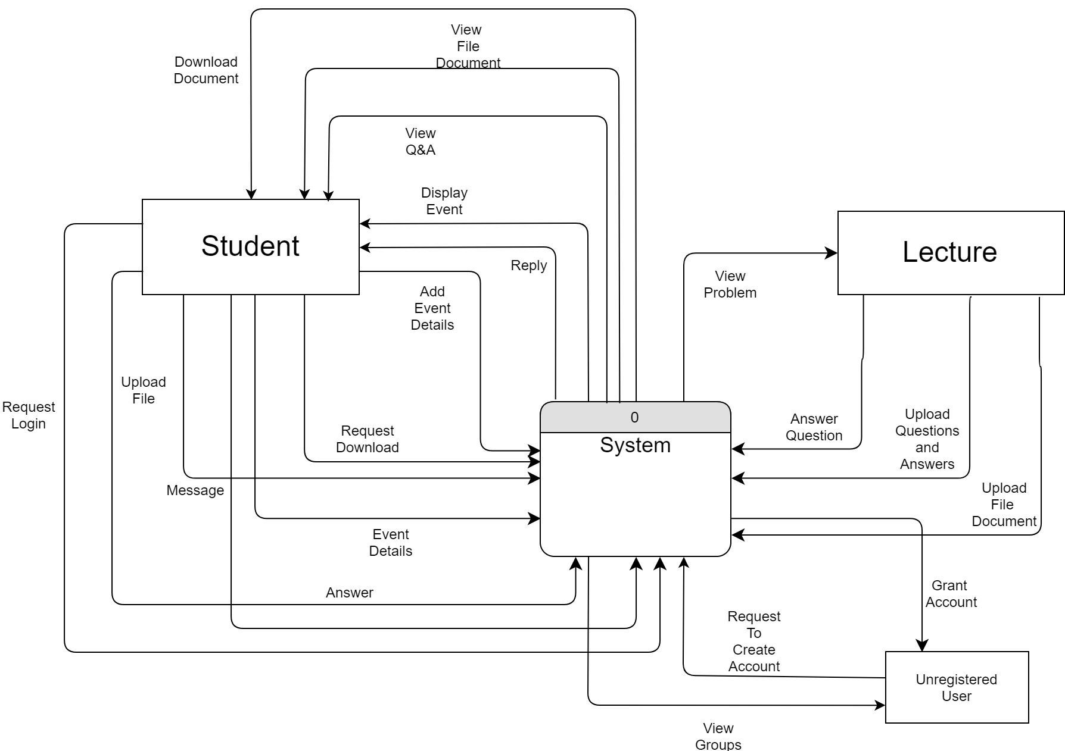

Figure 5.3: Level 0 Context Diagram

**5.4.1.2 Level-1 Context Diagram**

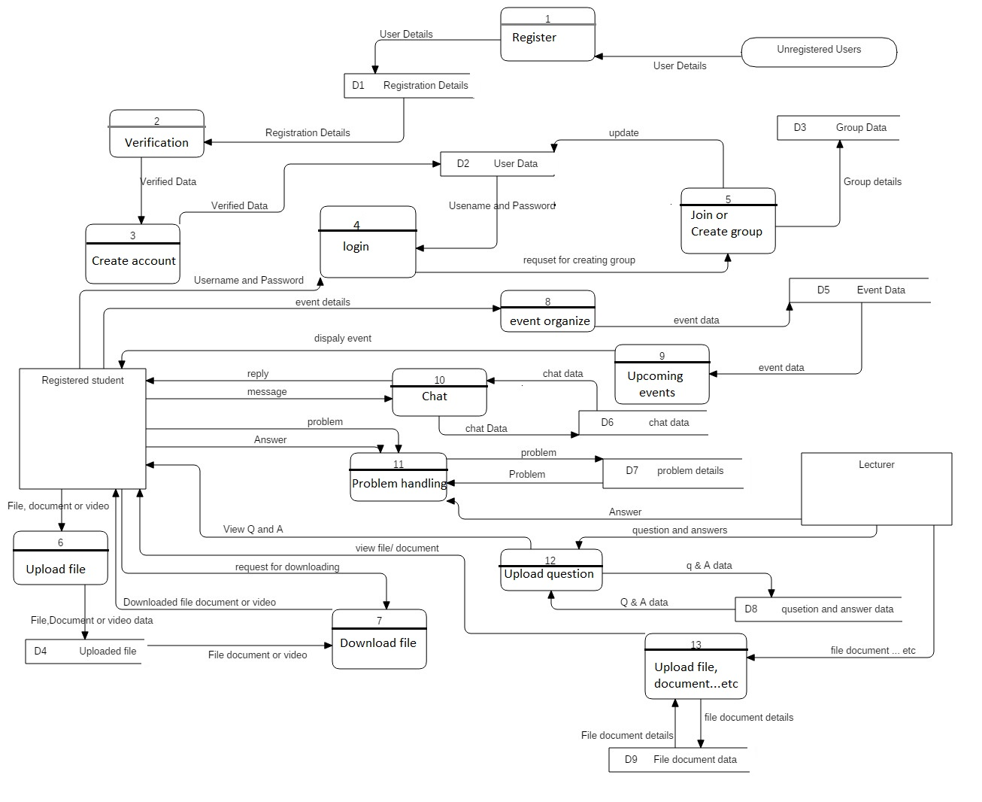

Figure 5.4: Context diagram

**5.4.2 Use case Diagram**

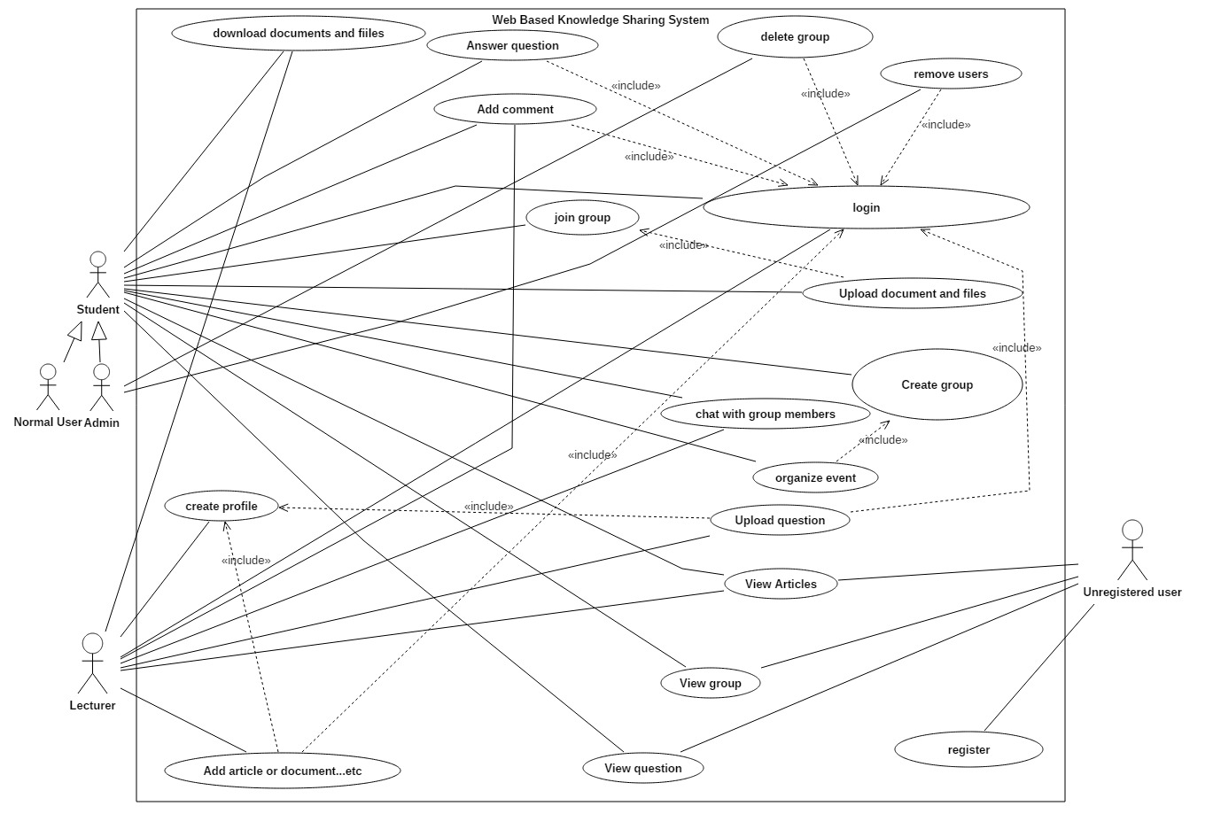Use case diagram specifies the interaction between users and their tasks.

Figure 5.5: Use case diagram

There are three kind of main actors in our system as student, lecturer and unregistered users. Student actor can be generalized as normal user and admin. Each actor has different tasks according to their role.

**5.4.3 Activity Diagram**

Activity diagrams specify the message flow from one activity to another activity. There are four different kind of activity diagrams in our system for different tasks.

**5.4.3.1 Activity diagram of Login process**

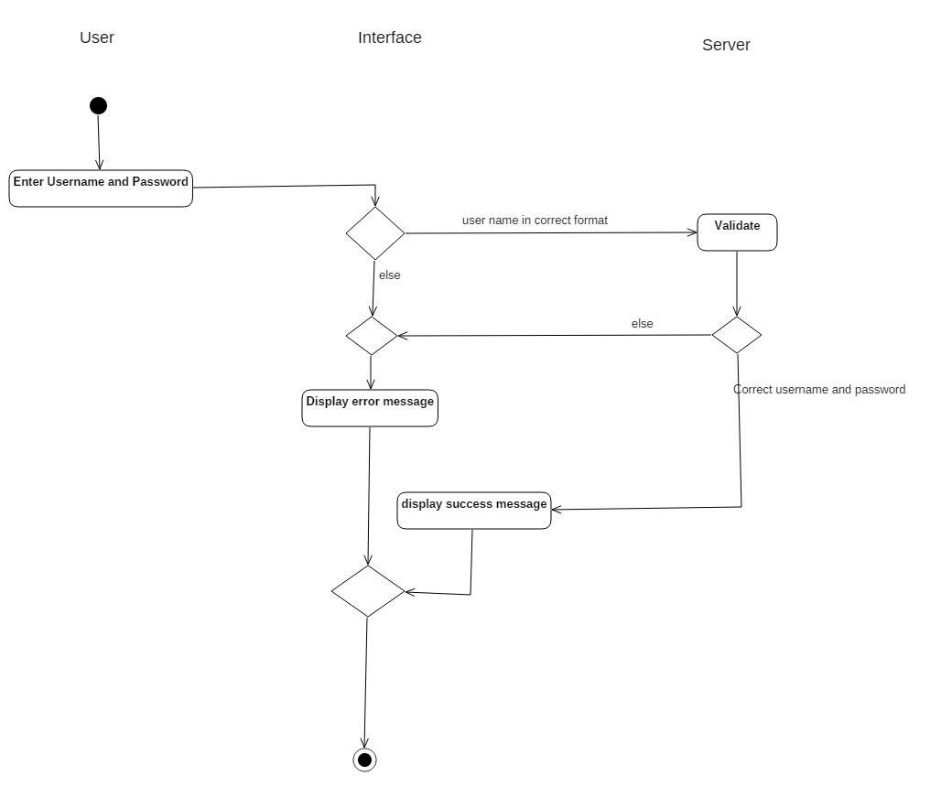

Figure 5.6: Activity diagram of login process

For the login process user, interface and server will be involved. Above activity diagram, specify the flow of activities related to the login process.

**5.4.3.2 Activity diagram of group handling process**

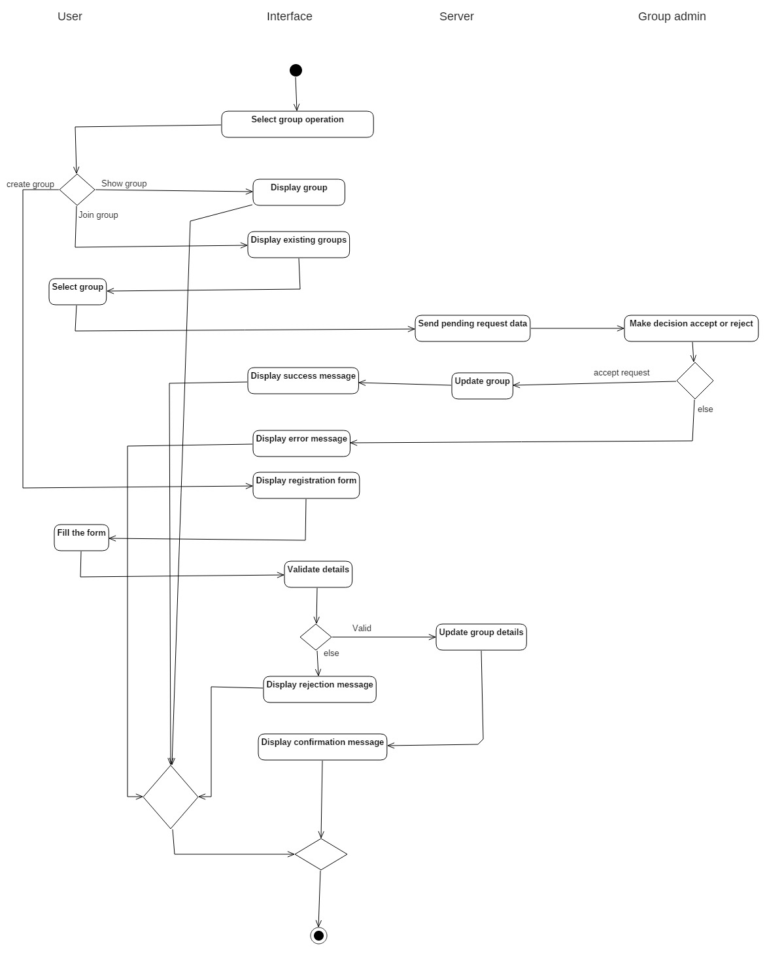

Figure 5.7: Activity diagram of group handling process.

This activity diagram specify the flow of activities involved in-group handling process. The interaction occurs within four main objects such as user, interface, server and group admin.

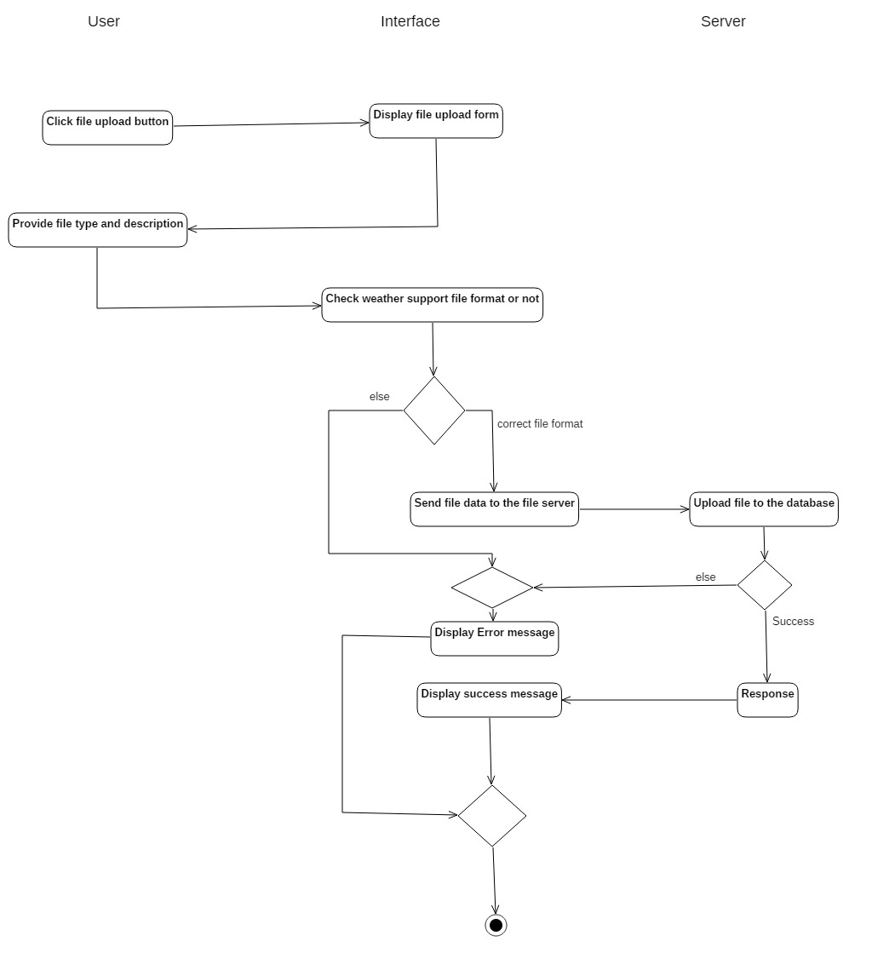**5.4.3.3 Activity diagram of final upload process**

Figure 5.8: Activity diagram of file uploading process

This activity diagram specifies the interaction within registered user, interface and server who are involving in file uploading process

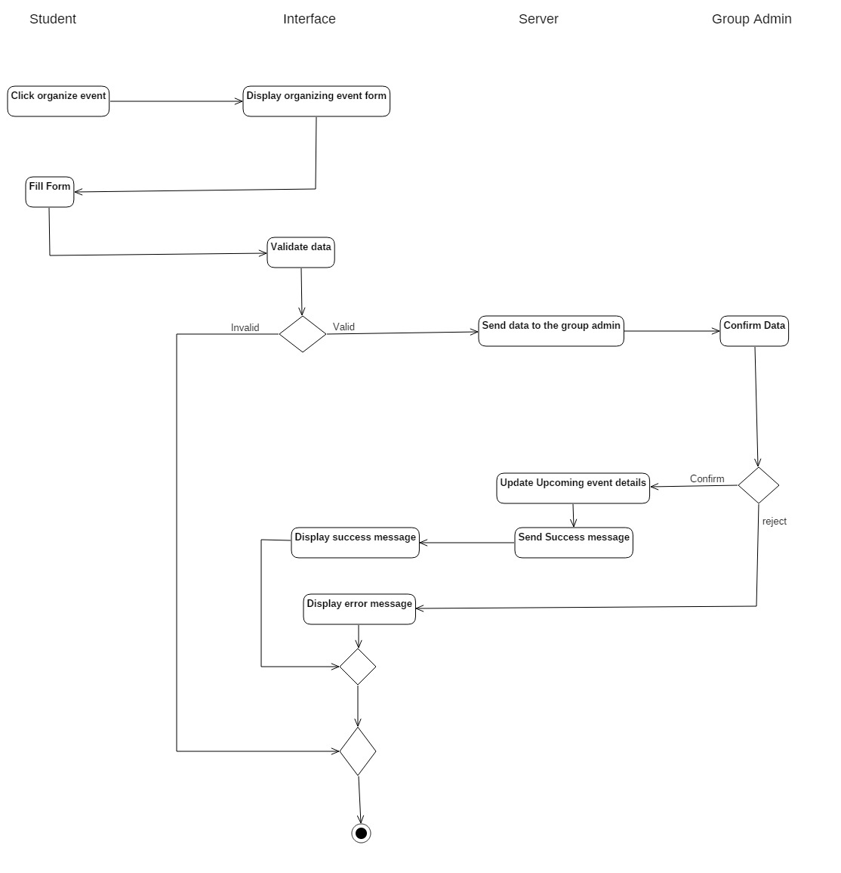**5.3.3.4 Activity diagram of event handling process**

Figure 5.9: Activity diagram of event handling process

Student, interface, server and group admin are the main objects involved in this scenario. By referring this activity diagram, we can identify the flow of activities, which related to event handling process.

**5.4.4 Sequence diagram**

Sequence diagrams describes the interaction between objects arranged in time sequence. In our system there are four different kind of sequence diagrams.

**5.4.4.1 Sequence diagram of login process**

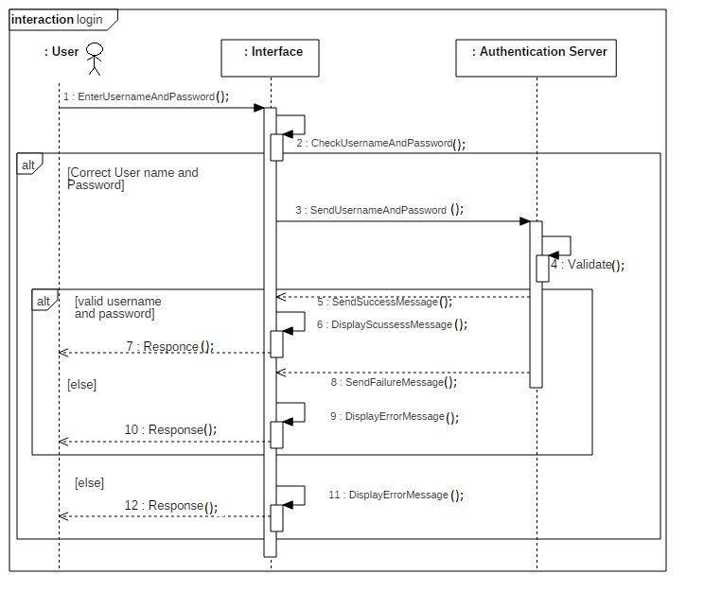

Figure 5.10: Sequence diagram of login process

Figure 5.6 Sequence diagram of Admin

This sequence diagram specifies the message passing sequence within objects according to time.

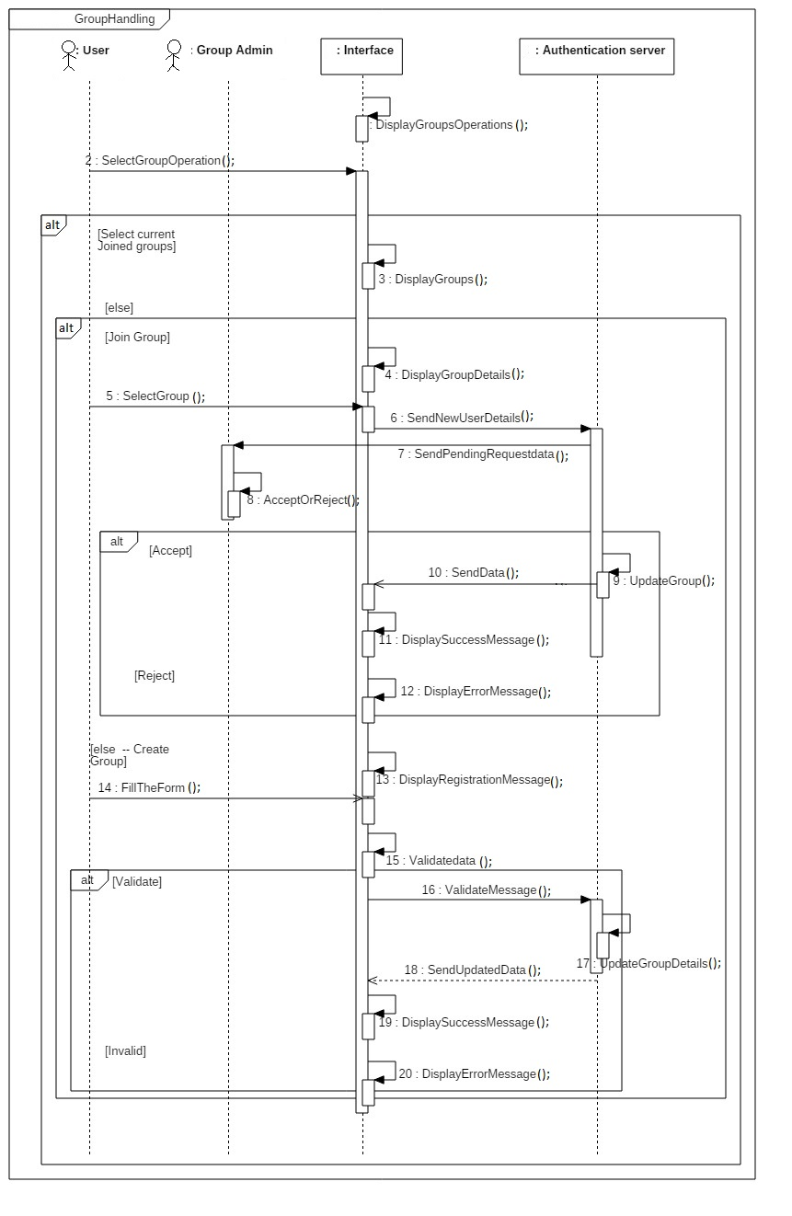**5.4.4.2 Sequence diagram of group handling process**

Figure 5.11: Sequence diagram of group handling process

This sequence diagram specifies the message passing sequence within objects related to the group handling process according to time.

**5.4.4.3 Sequence Diagram of file uploading process**

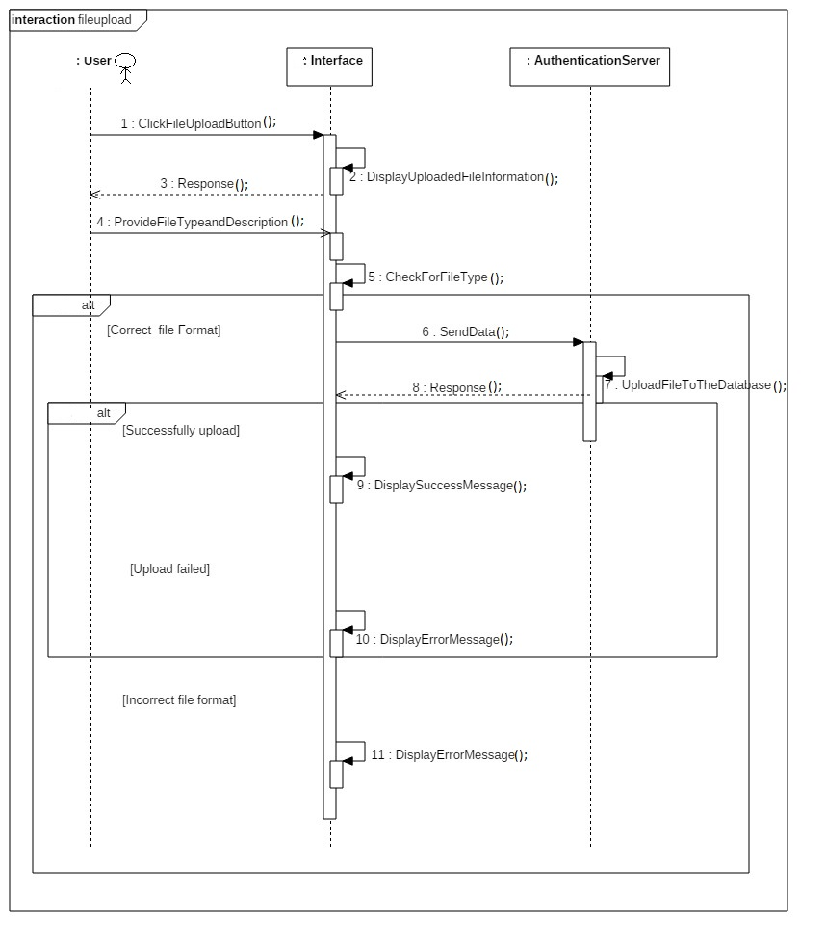

Figure 5.12: Sequence diagram of file uploading process

This sequence diagram specifies the message passing sequence within objects related to the file uploading process according to time period

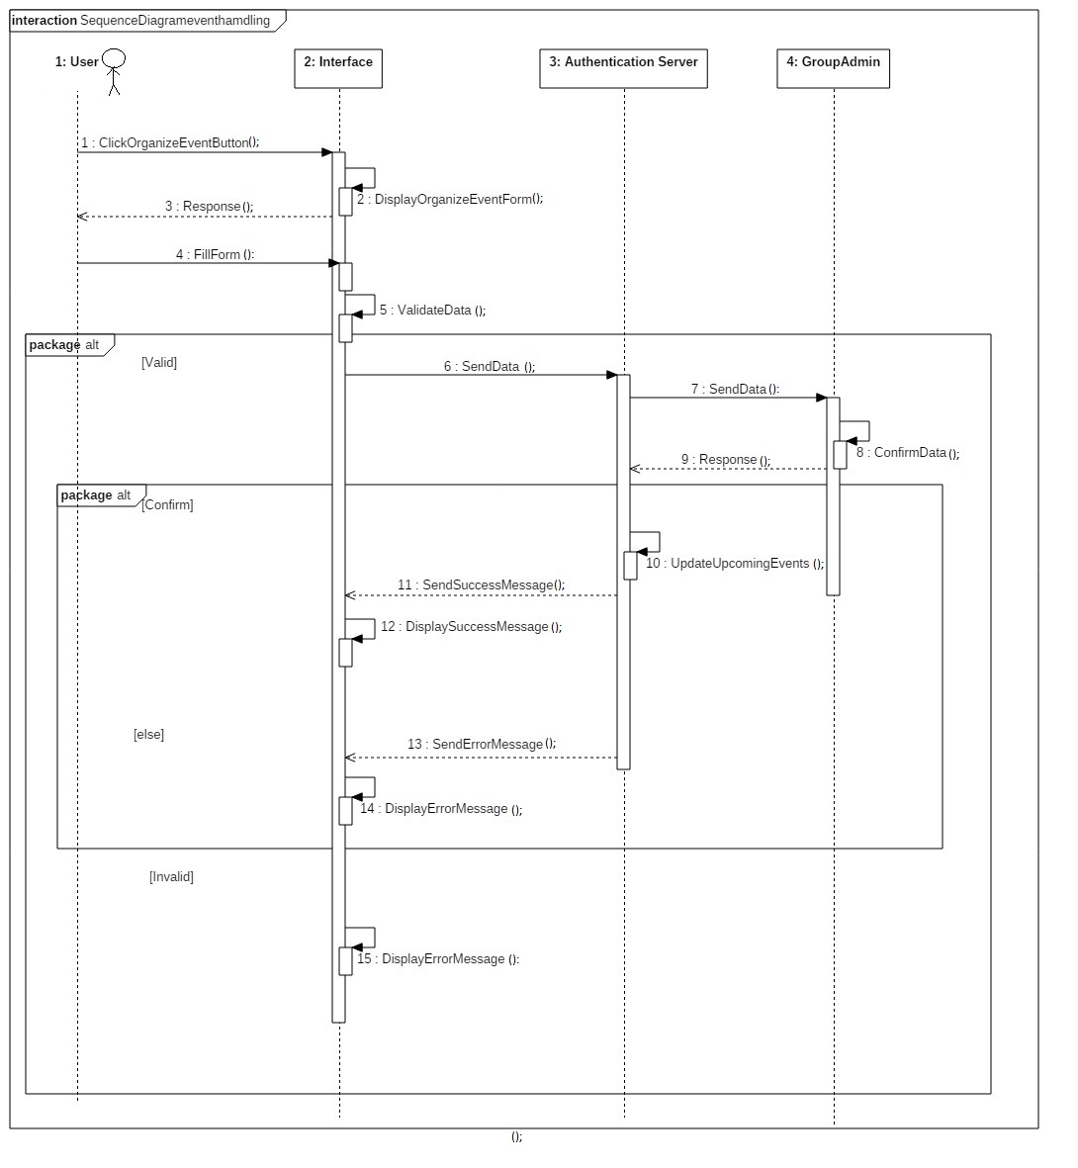**5.4.4.4 Sequence Diagram of event organizing process**

Figure 5.13: Sequence diagram of event organizing process

This sequence diagram specifies the message passing sequence within objects related to the event organizing process according to time period.

**5.4.5 Class Diagram**

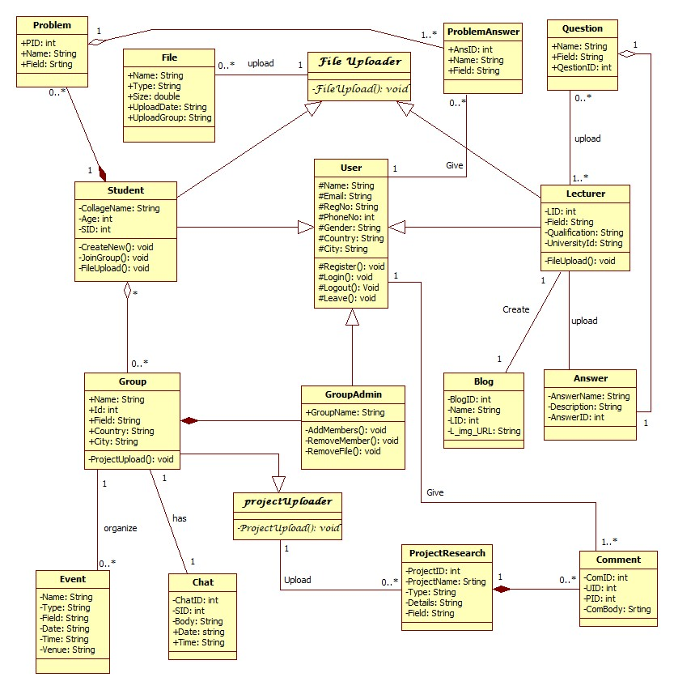Class diagram is a static diagram which includes classes, attributes of classes, methods and relationships among each classes.

Figure 5.14: Class diagram

We have identified seventeen classes in our system. To draw this class diagram we have used association, inheritance, and aggregation and composition technique

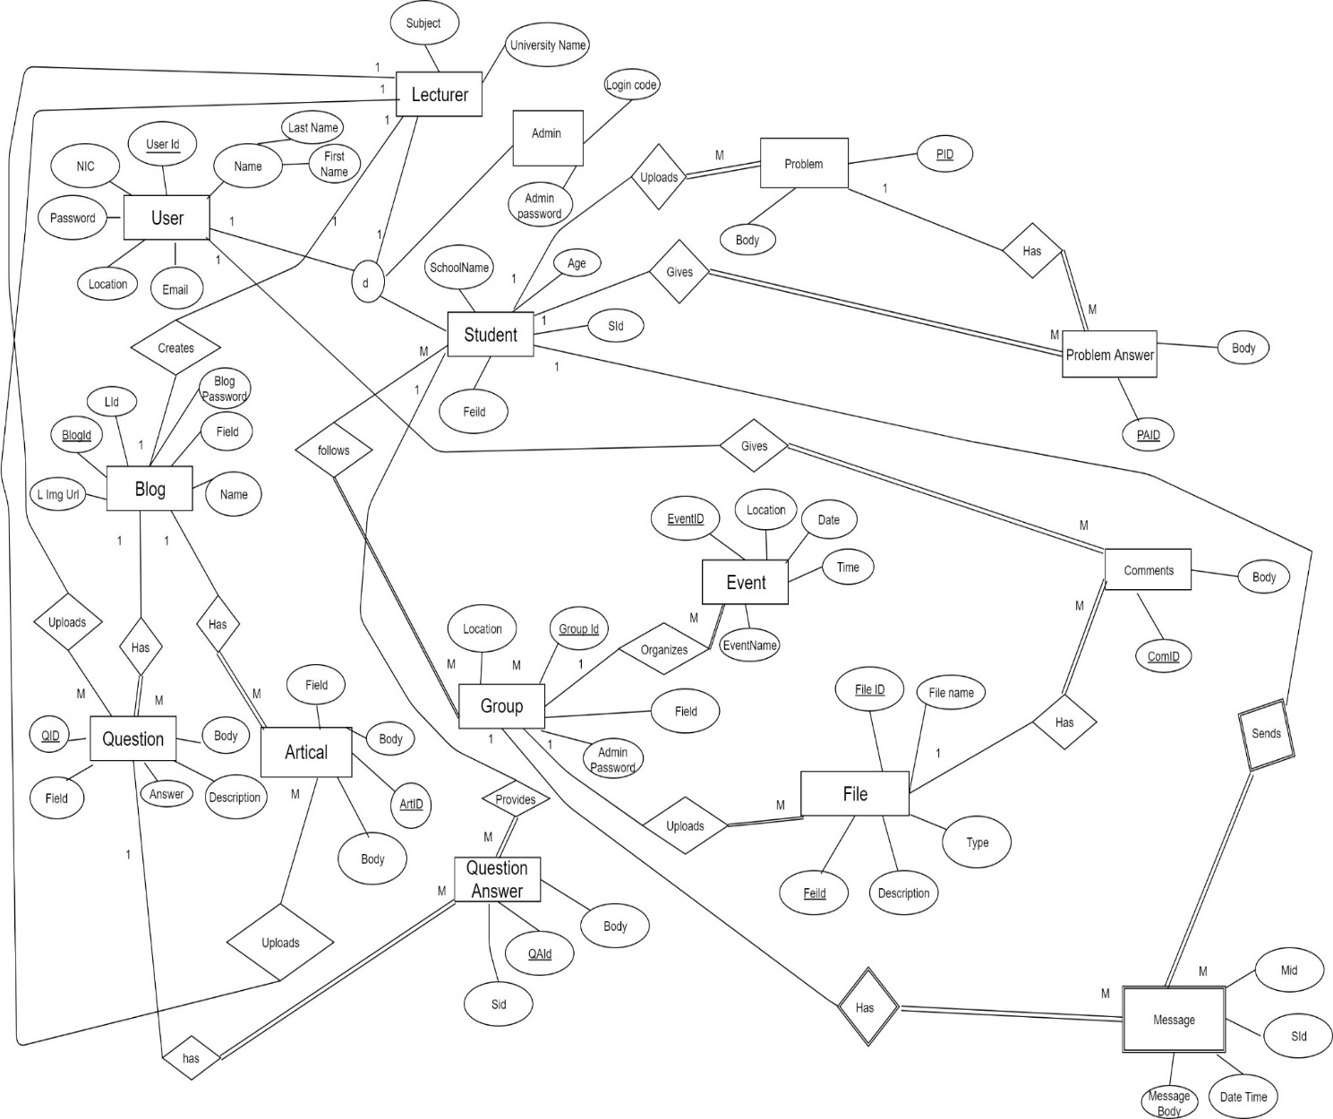**5.4.6 EER diagram**

Figure 5.15: EER diagram

EER means Enhanced Entity relationship model. This model describes general ER concepts and as well as additional concepts of super classes, sub classes, generalization and inheritance.

**5.5 Summary**

After understanding the customer requirements, we analyzed them in a proper manner to design the system. In this designing phase we understood there should be UML diagrams to get a clear idea about what we are actually going to implement. We understood four main modules of the system as User interface, database, mobile application and system. We studied a lot about UML diagrams and drew Use case diagrams, Activity diagrams, Class diagram, Sequence diagrams, context diagram and EER diagram. We have drawn 4 different activity diagrams and sequence diagrams for login process, group handling process, file uploading process and event organizing process

**Chapter 6**

**Implementation**

**6.1 Introduction**

In implementation process we focus on how to improve designed diagrams to an executable form. In this phase we convert visions and plans in to a reality. In this chapter we described how we implemented the project so far. This chapter will be described each module that is stated in the design diagram using flow charts [23].

**6.2 Implementation**

After we were chosen to develop this system we visited our company time to time. After discussing with the business analyst we gathered information and analyzed them. Then we designed our system by designing UML diagrams, EER diagram and context diagram. UML diagrams include Use case diagram, Activity diagram, Sequence diagram and class diagram [6]. Also we have designed the user interface and a part of database. We selected component based model as the software process model as it is minimizing time wasting and reducing overall system failures. As a development team it is easy to implement the system by integrating existing systems [10].

We have designed separate flow charts for the registration process, login process, group handling process, file uploading process and event organizing process.

**6.2.1 Register to the system**

Click on” Register”

Enter details

Click submit

Validate

Details are valid

Show “Registration is successful”

Show error message

No

Yes

Figure 6.1: Flow chart of registration process

**6.2.2 Login to the system**

Click on” Login”

Validate

Details are valid

Show error message

No

Yes

View profile

Input login details

Figure 6.2: Flow chart of login process

**6.2.3 Create /Join group**

Create a group

Search a group

Fill and submit form

Select “Join to a group”

Matched group

Display

“Successfully created a new group”

Result

Yes

No

Figure 6.3: Flow chart of create /join group

**6.2.4 Upload a file**

Select file type

Enter a description

Upload file

Successfully uploaded

Display” Successfully uploaded”

Display an error

No

Yes

Figure 6.4: Flow chart of File upload process

**6.2.5 Event Organizing (By Groups)**

Input event details

Click add event

Set visibility

Output event details

Successfully

uploaded

Display error message

Failed

[else]

Figure 6.5: Flow chart of event organizing process

**6.3 Summary**

In this chapter we have discussed how we implemented the system so far. We understood that understanding user requirements correctly is the main task before starting the project. To design the project, we used UML diagrams which support to look at the system in every possible angle. UML diagrams are a more powerful method of visualization and documenting software system design. Furthermore, we have designed flowcharts of each main processes in the system for more understanding. We designed 5 flow charts for separate processes like registration process, login process, group handling process, file uploading process and event organizing process. At this stage we have only implemented the interfaces and a part of database we have to do further work in future before finishing the system development.

**Chapter 7**

**Evaluation**

**7.1 Introduction**

Implementation progress of the system was discussed in the previous chapter. Now we are hoping to discuss about how we are planning to evaluate our system. Evaluation phase is mainly focused on users and also system will not be a success one unless user cannot gain what he/she expected from us. As a solution we decided to use questionnaire for several kind of users [5]. This will be a best way to overcome our failures and add more features according to user feedbacks and comments [25]. We are hoping to taking feedbacks from users in several periods and hoping to analyze them after gathering some number of feedbacks forms.

**7.2 Design of the Questionnaire**

We will evaluate our feedback forms for three kind of users. They are Undergraduates, non-undergraduate, school students. This category is based on their educational level, their understandable level and their requirements. We use five rating levels such as Very Good, Good, satisfactory, Poor and Very poor for several kind of evaluation aspects.

Table 7.1- Feedback Form for Undergraduates

**Level 2 – Project on Knowledge sharing System**

**Feedback Form for Undergraduate**

|  |  |  |  |  |  |  |
| --- | --- | --- | --- | --- | --- | --- |
| Title of the Project | |  | | | | |
| Group Name | |  | | | | |
| Date and Time | |  | | | | |
|  | | | | | | |
| No | Evaluation Aspects | Rating | | | | |
| Very Good | Good | Satisfactory | Poor | Very Poor |
| 01. | User friendliness of the application |  |  |  |  |  |
| 02. | Concept of the application |  |  |  |  |  |
| 03. | Responding speed of the application |  |  |  |  |  |
| 04. | User interactivity of the system |  |  |  |  |  |
| 05. | Support for education |  |  |  |  |  |
| 06. | Maintenances of the system |  |  |  |  |  |
| 07. | Usefulness of the application for developing countries |  |  |  |  |  |
| The overall grading of the proposed system:  Very Good – 5  Good - 4  Satisfactory - 3  Poor - 2  Very poor - 1 | | | | | | |
| Any Other Comments | | | | | | |
|  | | | | | | |
|  | | | | | | |
|  | | | | | | |
|  | | | | | | |
|  | | | | | | |
|  | | | | | | |
|  | | | | | | |
|  | | | | | | |
|  | | | | | | |

Table 7.2 - Feedback Form for Non-Undergraduates

**Level 2 – Project on Knowledge sharing System**

**Feedback Form for Non-Undergraduate**

|  |  |  |  |  |  |  |
| --- | --- | --- | --- | --- | --- | --- |
| Title of the Project | |  | | | | |
| Group Name | |  | | | | |
| Date and Time | |  | | | | |
| No | Evaluation Aspects | Rating | | | | |
| Very Good | Good | Satisfactory | Poor | Very Poor |
| 01. | User friendliness of the application |  |  |  |  |  |
| 02. | Concept of the application |  |  |  |  |  |
| 03. | Responding speed of the application |  |  |  |  |  |
| 04. | User interactivity of the system |  |  |  |  |  |
| 05. | Support for education |  |  |  |  |  |
| 06. | Ability of getting required learning materials without a payment |  |  |  |  |  |
| 07. | Maintenances of the system |  |  |  |  |  |
| 08. | Usefulness of the application for rural area students |  |  |  |  |  |
| The overall grading of the proposed system:  Very Good – 5  Good - 4  Satisfactory - 3  Poor - 2  Very poor - 1 | | | | | | |
| Any Other Comments | | | | | | |
|  | | | | | | |
|  | | | | | | |
|  | | | | | | |
|  | | | | | | |
|  | | | | | | |
|  | | | | | | |
|  | | | | | | |
|  | | | | | | |

Table 7.3- Feedback Form for School Students

**Level 2 – Project on Knowledge sharing System**

**Feedback Form for School Students**

|  |  |  |  |  |  |  |
| --- | --- | --- | --- | --- | --- | --- |
| Title of the Project | |  | | | | |
| Group Name | |  | | | | |
| Date and Time | |  | | | | |
|  | | | | | | |
| No | Evaluation Aspects | Rating | | | | |
| Very Good | Good | Satisfactory | Poor | Very Poor |
| 01. | User friendliness of the application |  |  |  |  |  |
| 02. | Concept of the application |  |  |  |  |  |
| 03. | Responding speed of the application |  |  |  |  |  |
| 04. | User interactivity of the system |  |  |  |  |  |
| 05. | Support for education |  |  |  |  |  |
| 06. | Usefulness of the application for School level students |  |  |  |  |  |
| The overall grading of the proposed system:  Very Good – 5  Good - 4  Satisfactory - 3  Poor - 2  Very poor - 1 | | | | | | |
| Any Other Comments | | | | | | |
|  | | | | | | |
|  | | | | | | |
|  | | | | | | |
|  | | | | | | |
|  | | | | | | |
|  | | | | | | |
|  | | | | | | |
|  | | | | | | |
|  | | | | | | |

**7.3 User Feedback Analysis**

Above mentionedcategorized feedback forms can be distributed among three kind of system users. We decided to distribute to at least sixty users of our system users (20 from each kind). After gathering all feedback forms we can get a quick overview of our system and can be identified our drawbacks and new functionalities to be added [15]. Analysis data can be used to further development and making changes of the system according to user requirements with the intention of satisfy users’ needs.

**7.4 Summary**

Evaluation progress is based on three kind of questionnaires with difference evaluation aspects. Users can rate each aspect based on five different rating levels according to their satisfactions about our system. Undergraduates have seven different evaluation aspects, Non- undergraduates have eight different aspects and school students have six different aspects to rate. And also user can give another comments in the other comments area. Ending with this chapter we could understand about different facts about our system. In the next chapter we hope to discuss about our current progress and about further work.

**Chapter 8**

**Discussion**

**8.1 Introduction**

In the previous chapter we discussed the evaluation process of the system. We attached 3 sample questionnaires related to 3 different users. Chapter 8 will be discussed what we have done so far and the remaining developments, in order to provide a productive software system.

**8.2 Achievement of objectives**

We started the project with the aim of develop a responsive, specified and dynamic web application and a mobile application making a direct connection between knowledge seekers with the use of technologies like JSON, JQUERY, CSS, SQL, PHP, Python, Angular JS and Jav. We have achieved following objectives accordingly.

* Study of Java, Java script, .net framework,asp.net framework, Android studio, MS SQL,
* Design and develop website
* Design database
* Discuss with the company to verify the progress

**8.3 Problem encountered**

To achieve above mentioned objectives we had to face many challenges during every stage in software development life cycle. We had only limited time to finish all these activities because we had end semester end exams meanwhile. And we were asked to use a new technology for the implementation process. Studying a new technology from its initial stage was a difficult task. We coded each module separately. Integrating these separated codes was a problem we faced. But it was resolved with the use of GitHub [20]. It was a complex task to be competitive with the existing systems. Therefore, we had to use proper and efficient methods to develop this system to failures

**8.4 Limitations of proposed solution**

Here are some few limitations in our solution

* + - Inability to video conferencing
    - Unavailability of bilingual support for the local users as the system is based on English. So the users must have English knowledge to work with system.
    - Users with less technical knowledge cannot use the system
    - Users have to pay the for internet supply.

**8.5 Future work**

Future work we have to do before releasing the final software system are as follows

* File uploading process of the system
* Event organizing process of the system
* Message passing process in group chats
* Mobile application of the system

**8.6 Summary**

In this last chapter of the report we paid our attention on the overview of the system we discussed about what we have done so far and the remaining work in order to finalize the system. We stated the unique features we have added to the system and how they improve the productivity of the system. After all we are planning to implement an efficient system for all knowledge seekers. Before starting the project, we did a small research on related existing systems. We added more features like Dashboard with google map and verifying an account by NIC or university identity card.

**Reference**

[1]. ASP.NET[online].Available:https://www.asp.net

[2]. Aziz Najibullah (800828), Gleeson darren (771129) , Kashif Muhammad (840722)

Barriers and Enablers of knowledge sharing. A qualitative study of ABB, Bombardier,Ericson and Siemens

[3]. Corrinne Ruff January 29,2016

Scholars Criticize Academia.edu proposal to Charge authors for recommendations

[4]. Christine J Villani and Douglas Atkins, 2000, School community journal,vol.10,

No 1, Spring/Summer Community based education

[5].<https://blog.intercom.com/how-to-analyze-customer-feedback-and-make-it-> actionable

[6.] http://creately.com/blog/diagrams/uml-diagram-types-examples/

[7]. https://developer.android.com/studio/preview/index.html

[8]. https://en.wikipedia.org/wiki/Bootstrap_(front-end_framework)

[9]. https://en.wikipedia.org/wiki/Server-side_scripting

[10]. https://en.wikipedia.org/wiki/Software_development_process

[11]. https://en.wikipedia.org/wiki/Systems_development_life

[12]. https://github.com

[13]. http://infolab.stanford.edu/~burback/watersluice/node11.html

[14]. https://moodle.com/

[15]. https://msdn.microsoft.com/en-us/library/bb924363.aspx

[16]. http://study.com/academy/lesson/requirement-gathering-analysis- phase-in-sdlc.html

[17]. https://www.academia.edu/

[18]. https://www.coursera.org/

[19]. https://www.infragistics.com/community/blogs/devtoolsguy/archive/2015/05/14

[20]. https://www.jetbrains.com/help/webstorm/using-github-integration.html

[21]. https://www.novell.com/documentation/nw65/web_mysql_nw/data/aj5bj52.html

[22]. http://www.seguetech.com/key-phases-software-development/

[23]. https://www.smartdraw.com/flowchart/

[24]. https://www.tutorialspoint.com/uml/uml_standard_diagrams.htm

[25]. https://www.ucy.ac.cy/ctl/en/activities/evaluation-questionnaires

[26]. https://www.upwork.com/hiring/development/how-scripting- languages-work/

[27]. https://www.w3schools.com/

[28]. https://www.yourwebskills.com/clientserver.php

[29]. Ronalou P. Paculan IV-Bravery SY.2012-2013 On the study of the effects Of Facebook On students

[30]. Steve Dale - Barriers to knowledge sharing, May 19, 2014

[31]. UNLC academic support center Study Group & College success.Adapted from the University of Laverne,Learning center,1/95

[32].Y.D She - Multi- criteria evaluation of the web based e learning system. A methodology based on Learner satisfaction and applications. Computers and Education, 50 (2008), pp. 894-905 \

**Appendix A**

**Individual contribution to the project**

**Pathirana I.M.P – 154075K**

I designed the website of the system. I studied about similar systems and their characteristics and weaknesses of W3 schools and GitHub. In the sample prototype, I validated the form using PHP. I connected the form with the database using PHP. When finding applicable technologies, I searched about asp.net and visual studio. Using YouTube tutorials and JavaPoint website. I designed four activity diagrams for each process and use case diagram after referring TutorialsPoint. I learnt how to use draw.io online tool to design activity and use case diagrams. I designed the back end. I connected the front-end forms to the back end using C# language. For that, I learnt C# language using tutorials. I wrote the functions to retrieve data from the database and display. I designed the feedback form of graduates. I searched about global unique identifier algorithms to uniquely identify users and apply those algorithms to the system. By helping to make the report, I studied how to make a proper project report.

**Rajapaksha R.P.M.P - 154090C**

First of all, I studied about similar approaches to our system and highlighted the similarities and differences. When creating the sample prototype, I added CSS codes and Java Script codes to its front end. I added snow effect to the prototype. I referred tutorials and watched YouTube in order to find about bootstrap technology. I drew 4 sequence diagrams for separate processes. For that I selected Star UML as the easiest tool to draw sequence diagrams after referring many UML diagram tools. I watched videos to learn about the features of sequence diagrams. I designed a feedback form for non-undergraduates. I designed the front end by using a template. I learnt how to edit a template according to our purpose by watching YouTube tutorials. I added CSS codes to the front end. I designed the front end of sign up forms. I learnt how to add a google map to a website. Moreover, I learnt how to make an excellent project report.

**Samaranayake S.N - 154107M**

My first task was to find similar approaches to our system. By referring internet, I found characteristics and weaknesses of Academia.edu and Facebook groups. When designing the sample prototype, I built the database using PHP scripts and MY SQL. For that, I referred TutorialsPoint and JavaPoint web sites to learn how to write quarries in a database. I drew the top-level architecture diagram of the system. I was responsible for designing the EER diagram. I studied about EER diagrams by watching YouTube tutorials and other related websites. After referring suitable tools to draw an EER I found draw.io online tool as the easiest method. My next task was to map the EER diagram to relational model. When normalizing the relational model, I got guidance from lecturers, I followed my past lecture notes and YouTube videos as this is the basis of database creation. I studied how to create the database using Microsoft SQL server management studio and how to add constraints to a database. I designed the back end of login form and leave using asp.net. Furthermore, I learnt how to make a project report according standard formats.

**Munasinghe L.T. - 154198N**

When drawing UML diagrams I wanted to draw a level 0 context diagram and a level 1 context diagram. I searched for tools which can be used to draw context diagrams. Then I selected draw.io online tool as the easiest tool. I studied how to draw a correct context diagram by using tutorials and watching YouTube videos. Our group members decided to design a sample prototype to be familiar with technologies. When creating that sample, I referred more about how to design a HTML form. I learnt about JavaScript by referring W3 Schools, TutorialsPoint and JavaPoint to implement the sample. When coming in to our actual system I studied how to design the front end by editing a template and how to add external JavaScript and CSS. I designed the login form and registration form. I learnt how to add a google map to a web page by studying more about related tags. And also I gave my fullest support when making the interim report.

**Madusanka M.A.D.H - 154199T**

When finding similar approaches, I found Courserra and Moodle from referring internet. Then I compared their characteristics and weaknesses with our proposed solution. Our group built a sample prototype. In that website I designed the front end using HTML. For that I followed tutorials in JavaPoint and W3 Schools. I designed the module diagram of the system. I watched YouTube tutorials to learn about HTML tags. I designed the form of group registration. I referred tutorials to learn how to draw a class diagram. I watched videos to learn how to use Star UML tools in order to draw a class diagram correctly. I referred internet and watched YouTube tutorials about flowcharts. I wrote the content in the front end. I studied how to work with Microsoft SQL server management studio in order to create database tables. I studied how to write quarries by referring JavaPoint.com and YouTube. I designed a feedback form for school students. I gave my fullest support to make the interim report.

**Appendix B**

**Source code**

At this interim level, we have mapped and normalized the entire database. We have built the entire database using MS SQL. We have added foreign key constraints to the database. Using Visual studio, C#, CSS, JavaScript and Asp.net we have designed the front end up to some level. We have connected the front end with the database. We have designed user registration module, login module, group creation module and leave from the system module.

**Login.aspx**

<%@ Page Language="C#"AutoEventWireup="true" CodeBehind="Login.aspx.cs" Inherits="Study_Groups.WebForm3" %>

<!DOCTYPE html>

<html xmlns="http://www.w3.org/1999/xhtml">

<head runat="server">

<title></title>

<link href="Style.css" rel="stylesheet" />

<style type="text/css">

body {

background-image:url(../css/Background.jpg);

}

.auto-style1 {

position: relative;

z-index: 9;

width: 283px;

left: 507px;

top: 80px;

height: 308px;

}

.auto-style2 {

width: 167px;

}

.auto-style3 {

position: relative;

z-index: 9;

width: 319px;

left: 68px;

top: 0px;

height: 35px;

}

.auto-style4 {

width: 202px;

}

.auto-style5 {

width: 319px;

}

.auto-style6 {

width: 129px;

}

.auto-style7 {

width: 98px;

height: 36px;

}

.auto-style9 {

width: 92px;

height: 37px;

margin-top: 0px;

}

.auto-style10 {

height: 947px;

}

</style>

</head>

<body>

<form id="form1" runat="server" class="auto-style10">

<table class="auto-style1" style="background-color: #CCFFFF">

<tr>

<td class="auto-style2">&nbsp;</td>

<td class="auto-style3"><strong>LogIn Page</strong></td>

<td>&nbsp;</td>

</tr>

<tr>

<td class="auto-style6">E-mail</td>

<td class="auto-style5">

<asp:TextBox ID="TextBoxemail" runat="server"></asp:TextBox>

</td>

<td class="auto-style7"></td>

</tr>

<tr>

<td class="auto-style4">Password</td>

<td class="auto-style5">

<asp:TextBox ID="TextBoxPassword" runat="server" TextMode="Password"></asp:TextBox>

</td>

<td>&nbsp;</td>

</tr>

<tr>

<td>&nbsp;</td>

<td class="auto-style5">

<asp:Button ID="Button1" CssClass="button" runat="server" OnClick="Button1_Click" Text="Login" Width="92px" Height="35px" />

&nbsp;<em><strong>&nbsp;</strong></em><input id="Reset1" type="reset" value="reset" class="auto-style9" /></td>

<td>&nbsp;</td>

</tr>

<tr>

<td>&nbsp;</td>

<td class="auto-style5"><em><strong>

<asp:HyperLink ID="HyperLinkSignUP" runat="server" CssClass="main-navigation" NavigateUrl="~/LecturerRegistation.aspx">New Lecture Sign Up</asp:HyperLink>

</strong></em></td>

<td>&nbsp;</td>

</tr>

<tr>

<td>&nbsp;</td>

<td class="auto-style5"><em><strong>

<asp:HyperLink ID="HyperLinkNewstudent" runat="server" CssClass="main-navigation" NavigateUrl="~/StudentRegistation.aspx">New Student Sign Up</asp:HyperLink>

</strong></em></td>

<td>&nbsp;</td>

</tr>

</table>

</form>

</body>

</html>

**Login aspx.cs**

using System;

using System.Collections.Generic;

using System.Linq;

using System.Web;

using System.Web.UI;

using System.Web.UI.WebControls;

using System.Data.SqlClient;

using System.Configuration;

namespace Study_Groups

{

public partial class WebForm3 : System.Web.UI.Page

{

protected void Page_Load(object sender, EventArgs e)

{

}

protected void Button1_Click(object sender, EventArgs e)

{

SqlConnection con = new SqlConnection(ConfigurationManager.ConnectionStrings["Study Groups BudusaranaiConnectionString2"].ConnectionString);

con.Open();

String checkuser = "SELECT count(*) FROM Users where email ='" + TextBoxemail.Text + "'";

SqlCommand com = new SqlCommand(checkuser, con);

int temp = Convert.ToInt32(com.ExecuteScalar().ToString());

if (temp == 1)

{

String checkpassword = "SELECT Password from Users where email ='" + TextBoxemail.Text + "'";

SqlCommand passcom = new SqlCommand(checkpassword, con);

String Password = passcom.ExecuteScalar().ToString().Replace(" ","");

if(Password == TextBoxPassword.Text)

{

Session["New"] = TextBoxemail.Text;

Response.Write("Password is correct");

Response.Redirect("Users.aspx");

}

else

{

Response.Write("Password is not correct");

}

con.Close();

//Response.Write("User alrady exsits");

}

//end of the session

// com.ExecuteNonQuery();

}

protected void Button2_Click(object sender, EventArgs e)

{

}

}}

**Student registration aspx**

<%@ Page Language="C#" AutoEventWireup="true" CodeBehind="StudentRegistation.aspx.cs" Inherits="Study_Groups.WebForm2" %>

<!DOCTYPE html>

<html xmlns="http://www.w3.org/1999/xhtml">

<head runat="server">

<title></title>

<style type="text/css">

.auto-style1 {

width: 100%;

}

.auto-style3 {

font-size: medium;

text-align: right;

color: #0066FF;

width: 222px;

}

.auto-style4 {

font-size: medium;

text-align: right;

color: #0066FF;

width: 222px;

height: 23px;

}

.auto-style5 {

height: 23px;

}

</style>

</head>

<body>

<form id="form1" runat="server">

<div>

</div>

<table class="auto-style1">

<tr>

<td class="auto-style3"><strong><em>First Name</em></strong></td>

<td>

<asp:TextBox ID="TextBoxFirstName" runat="server"></asp:TextBox>

</td>

<td>&nbsp;</td>

</tr>

<tr>

<td class="auto-style3"><strong><em>Last Name</em></strong></td>

<td>

<asp:TextBox ID="TextBoxLastName" runat="server" OnTextChanged="TextBox2_TextChanged"></asp:TextBox>

</td>

<td>&nbsp;</td>

</tr>

<tr>

<td class="auto-style3"><strong><em>e-mail</em></strong></td>

<td>

<asp:TextBox ID="TextBoxemail" runat="server"></asp:TextBox>

</td>

<td>&nbsp;</td>

</tr>

<tr>

<td class="auto-style3"><strong><em>Location</em></strong></td>

<td>

<asp:TextBox ID="TextBoxLocation" runat="server"></asp:TextBox>

</td>

<td>&nbsp;</td>

</tr>

<tr>

<td class="auto-style3"><strong>Field</strong></td>

<td>

<asp:TextBox ID="TextBoxField" runat="server"></asp:TextBox>

</td>

<td>&nbsp;</td>

</tr>

<tr>

<td class="auto-style3"><strong>School Name</strong></td>

<td>

<asp:TextBox ID="TextBoxSchoolName" runat="server"></asp:TextBox>

</td>

<td>&nbsp;</td>

</tr>

<tr>

<td class="auto-style4"><strong>Age</strong></td>

<td class="auto-style5">

<asp:TextBox ID="TextBoxAge" runat="server"></asp:TextBox>

</td>

<td class="auto-style5"></td>

</tr>

<tr>

<td class="auto-style3"><strong><em>NIC</em></strong></td>

<td>

<asp:TextBox ID="TextBoxNIC" runat="server"></asp:TextBox>

</td>

<td>&nbsp;</td>

</tr>

<tr>

<td class="auto-style3"><strong><em>Password</em></strong></td>

<td>

<asp:TextBox ID="TextBoxPassword" runat="server"></asp:TextBox>

</td>

<td>&nbsp;</td>

</tr>

<tr>

<td class="auto-style3"><strong><em>Confirm Password</em></strong></td>

<td>

<asp:TextBox ID="TextBoxConfirmPWD" runat="server"></asp:TextBox>

</td>

<td>&nbsp;</td>

</tr>

<tr>

<td>&nbsp;</td>

<td>

<asp:Button ID="Button1" runat="server" OnClick="Button1_Click" Text="Register" />

<input id="Reset1" type="reset" value="reset" /></td>

<td>&nbsp;</td>

</tr>

<tr>

<td>&nbsp;</td>

<td>&nbsp;</td>

<td>&nbsp;</td>

</tr>

</table>

</form>

</body>

</html>

**Student registration asxpx.cs**

using System;

using System.Collections.Generic;

using System.Linq;

using System.Web;

using System.Web.UI;

using System.Web.UI.WebControls;

using System.Data.SqlClient;

using System.Configuration;

namespace Study_Groups

{

public partial class WebForm2 : System.Web.UI.Page

{

protected void Page_Load(object sender, EventArgs e)

{

}

protected void TextBox2_TextChanged(object sender, EventArgs e)

{

}

protected void Button1_Click(object sender, EventArgs e)

{

try

{

//algorithum for globle user identifier

Guid newGUID = Guid.NewGuid();

SqlConnection con = new SqlConnection(ConfigurationManager.ConnectionStrings["Study Groups BudusaranaiConnectionString2"].ConnectionString);

con.Open();

String userinsertquary = "insert into Users (UserId,FirstName,LastName,email,Location,NIC,Password) values (@UID,@FName,@LName,@eml,@loca,@ni,@pwd)";

SqlCommand com = new SqlCommand(userinsertquary, con);

com.Parameters.AddWithValue("@UID", newGUID.ToString());

com.Parameters.AddWithValue("@FName", TextBoxFirstName.Text);

com.Parameters.AddWithValue("@LName", TextBoxLastName.Text);

com.Parameters.AddWithValue("@eml", TextBoxemail.Text);

com.Parameters.AddWithValue("@loca", TextBoxLocation.Text);

com.Parameters.AddWithValue("@ni", TextBoxNIC.Text);

com.Parameters.AddWithValue("@pwd", TextBoxPassword.Text);

com.ExecuteNonQuery();

Response.Write("Hariyata demma wede hari mcn");

// For lecturers

String lectureinsertquary = "insert into Student (UserId,Field,SchoolName,Age) values (@UID,@Field,@SchoolName,@Age)";

SqlCommand com2 = new SqlCommand(lectureinsertquary, con);

com2.Parameters.AddWithValue("@UID",newGUID.ToString());

com2.Parameters.AddWithValue("@Field",TextBoxField.Text);

com2.Parameters.AddWithValue("@SchoolName",TextBoxSchoolName.Text);

com2.Parameters.AddWithValue("@Age",TextBoxAge.Text);

com2.ExecuteNonQuery();

con.Close();

Response.Redirect("Manager.aspx");

}

catch (Exception ex)

{

Response.Write("Error occurs " + ex.ToString());

}

}

}

}

**Lecturer registration aspx**

<%@ Page Language="C#" AutoEventWireup="true" CodeBehind="LecturerRegistation.aspx.cs" Inherits="Study_Groups.WebForm1" %>

<!DOCTYPE html>

<html xmlns="http://www.w3.org/1999/xhtml">

<head runat="server">

<title></title>

<style type="text/css">

.auto-style1 {

margin-left: 280px;

}

.auto-style2 {

width: 100%;

}

.auto-style3 {

font-size: medium;

text-align: right;

color: #0066FF;

width: 222px;

}

.auto-style4 {

width: 222px;

}

.auto-style5 {

width: 222px;

height: 23px;

}

.auto-style6 {

height: 23px;

}

.auto-style7 {

font-size: medium;

text-align: right;

color: #0066FF;

width: 222px;

height: 26px;

}

.auto-style8 {

height: 26px;

}

</style>

</head>

<body>

<form id="form1" runat="server">

<div>

<p class="auto-style1">

<table class="auto-style2">

<tr>

<td class="auto-style3"><strong><em>First Name</em></strong></td>

<td>

<asp:TextBox ID="TextBoxFirstName" runat="server"></asp:TextBox>

</td>

<td>&nbsp;</td>

</tr>

<tr>

<td class="auto-style3"><strong><em>Last Name</em></strong></td>

<td>

<asp:TextBox ID="TextBoxLastName" runat="server"></asp:TextBox>

</td>

<td>&nbsp;</td>

</tr>

<tr>

<td class="auto-style3"><strong><em>e-mail</em></strong></td>

<td>

<asp:TextBox ID="TextBoxemail" runat="server"></asp:TextBox>

</td>

<td>&nbsp;</td>

</tr>

<tr>

<td class="auto-style3"><strong><em>Location</em></strong></td>

<td>

<asp:TextBox ID="TextBoxLocation" runat="server"></asp:TextBox>

</td>

<td>&nbsp;</td>

</tr>

<tr>

<td class="auto-style7"><strong><em>Subject</em></strong></td>

<td class="auto-style8">

<asp:TextBox ID="TextBoxSUbject" runat="server"></asp:TextBox>

</td>

<td class="auto-style8">&nbsp;</td>

</tr>

<tr>

<td class="auto-style3"><strong><em>University</em></strong></td>

<td>

<asp:TextBox ID="TextBoxUniversity" runat="server"></asp:TextBox>

</td>

<td>&nbsp;</td>

</tr>

<tr>

<td class="auto-style3"><strong><em>NIC</em></strong></td>

<td>

<asp:TextBox ID="TextBoxNIC" runat="server"></asp:TextBox>

</td>

<td>&nbsp;</td>

</tr>

<tr>

<td class="auto-style3"><strong><em>Password</em></strong></td>

<td>

<asp:TextBox ID="TextBoxPassword" runat="server" TextMode="Password"></asp:TextBox>

</td>

<td>&nbsp;</td>

</tr>

<tr>

<td class="auto-style3"><strong><em>Confirm Password</em></strong></td>

<td>

<asp:TextBox ID="TextBoxConfirmPassword" runat="server"></asp:TextBox>

</td>

<td>&nbsp;</td>

</tr>

<tr>

<td class="auto-style4">&nbsp;</td>

<td>

<asp:Button ID="ButtonRegister" runat="server" OnClick="ButtonRegister_Click" Text="Register" />

<input id="Reset1" type="reset" value="reset" /></td>

<td>&nbsp;</td>

</tr>

<tr>

<td class="auto-style5"></td>

<td class="auto-style6"></td>

<td class="auto-style6"></td>

</tr>

<tr>

<td class="auto-style5"></td>

<td class="auto-style6"></td>

<td class="auto-style6"></td>

</tr>

</table>

Registation page for lectures</p>

</div>

</form>

</body>

</html>

**Lecturer registration asxpx.cs**

using System;

using System.Collections.Generic;

using System.Linq;

using System.Web;

using System.Web.UI;

using System.Web.UI.WebControls;

using System.Data.SqlClient;

using System.Configuration;

namespace Study_Groups

{

public partial class WebForm1 : System.Web.UI.Page

{

protected void Page_Load(object sender, EventArgs e)

{

}

protected void ButtonRegister_Click(object sender, EventArgs e)

{

try

{

//algorithum for globle user identifier

Guid newGUID = Guid.NewGuid();

SqlConnection con = new SqlConnection(ConfigurationManager.ConnectionStrings["Study Groups BudusaranaiConnectionString2"].ConnectionString);

con.Open();

String userinsertquary = "insert into Users (UserId,FirstName,LastName,email,Location,NIC,Password) values (@UID,@FName,@LName,@eml,@loca,@ni,@pwd)";

SqlCommand com = new SqlCommand(userinsertquary,con);

com.Parameters.AddWithValue("@UID", newGUID.ToString());

com.Parameters.AddWithValue("@FName", TextBoxFirstName.Text);

com.Parameters.AddWithValue("@LName", TextBoxLastName.Text);

com.Parameters.AddWithValue("@eml", TextBoxemail.Text);

com.Parameters.AddWithValue("@loca", TextBoxLocation.Text);

com.Parameters.AddWithValue("@ni", TextBoxNIC.Text);

com.Parameters.AddWithValue("@pwd", TextBoxPassword.Text);

com.ExecuteNonQuery();

Response.Write("Hariyata demma wede hari mcn");

// for lecturers

String lectureinsertquary = "insert into Lecturer (UserId,Subject,UniversityName) values (@UID,@subject,@university)";

SqlCommand com2 = new SqlCommand(lectureinsertquary, con);

com2.Parameters.AddWithValue("@UID", newGUID.ToString());

com2.Parameters.AddWithValue("@subject", TextBoxSUbject.Text);

com2.Parameters.AddWithValue("@university", TextBoxUniversity.Text);

com2.ExecuteNonQuery();

con.Close();

Response.Redirect("Manager.aspx");

}

catch (Exception ex)

{

Response.Write("Error ekak insert karaddi poddak balanna " + ex.ToString());

}

}

}

}

**Leave aspx**

<%@ Page Language="C#" AutoEventWireup="true" CodeBehind="Leave.aspx.cs" Inherits="Study_Groups.WebForm4" %>

<!DOCTYPE html>

<html xmlns="http://www.w3.org/1999/xhtml">

<head runat="server">

<title></title>

<style type="text/css">

.auto-style1 {

width: 100%;

}

.auto-style2 {

height: 26px;

}

</style>

</head><body>

<form id="form1" runat="server">

<div>

<table class="auto-style1">

<tr>

<td class="auto-style2">

<asp:Label ID="Labelemail" runat="server" Text="e-mail"></asp:Label>

</td>

<td class="auto-style2">

<asp:TextBox ID="TextBoxemail" runat="server"></asp:TextBox>

</td>

<td class="auto-style2"></td>

</tr>

<tr>

<td class="auto-style2">

<asp:Label ID="LabelPassword" runat="server" Text="Password"></asp:Label>

</td>

<td class="auto-style2">

<asp:TextBox ID="TextBoxPassword" runat="server"></asp:TextBox>

</td>

<td class="auto-style2"></td>

</tr>

<tr>

<td>&nbsp;</td>

<td>

<asp:Button ID="Button1" runat="server" OnClick="Button1_Click" style="height: 26px" Text="Confirm &amp; leave" />

<asp:Button ID="ButtonRegister" runat="server" OnClick="ButtonRegister_Click" Text="Register" />

</td>

<td>&nbsp;</td>

</tr>

<tr>

<td>&nbsp;</td>

<td>&nbsp;</td>

<td>&nbsp;</td>

</tr>

<tr>

<td>&nbsp;</td>

<td>&nbsp;</td>

<td>&nbsp;</td>

</tr>

</table>

</div>

</form>

</body>

</html>

**Leave aspx.cs**

using System;

using System.Collections.Generic;

using System.Linq;

using System.Web;

using System.Web.UI;

using System.Web.UI.WebControls;

using System.Data.SqlClient;

using System.Configuration;

namespace Study_Groups

{

public partial class WebForm4 : System.Web.UI.Page

{

protected void Page_Load(object sender, EventArgs e)

{

}

protected void Button1_Click(object sender, EventArgs e)

{

SqlConnection con = new SqlConnection(ConfigurationManager.ConnectionStrings["Study Groups BudusaranaiConnectionString2"].ConnectionString);

con.Open();

// user kenekda kyl balanawa

String checkuser = "SELECT count(*) FROM Users where email ='" + TextBoxemail.Text + "'";

SqlCommand com = new SqlCommand(checkuser, con)

int temp = Convert.ToInt32(com.ExecuteScalar().ToString());

if (temp == 1)

{

String checkpassword = "SELECT Password from Users where email ='" + TextBoxemail.Text + "'";

SqlCommand passcom = new SqlCommand(checkpassword, con);

String Password = passcom.ExecuteScalar().ToString().Replace(" ", "");

if (Password == TextBoxPassword.Text)

{

// Session["New"] = TextBoxemail.Text;

// Response.Write("Password is correct");

//delete user from User table

String deleteuser = "DELETE FROM Users where email ='" + TextBoxemail.Text + "'";

SqlCommand comdeletuser = new SqlCommand(deleteuser, con);

comdeletuser.ExecuteNonQuery();

//lecture delete

try

{

String deleteLecturer = "DELETE FROM Users where email ='" + TextBoxemail.Text + "'";

SqlCommand comdeleteLecturer = new SqlCommand(deleteLecturer, con);

comdeletuser.ExecuteNonQuery();

}

catch

{

Response.Write("User is not a lecture");

}

// delete student

try

{

String deletestuent = "DELETE FROM Users where email ='" + TextBoxemail.Text + "'";

SqlCommand comdeletestuent = new SqlCommand(deletestuent, con);

comdeletuser.ExecuteNonQuery();

}

catch

{

Response.Write("user is not a student");

}

Response.Redirect("Manager.aspx");

}

else

{

Response.Write("Password is not correct");

}

con.Close();

//Response.Write("User alrady exsits");

}

}

protected void ButtonRegister_Click(object sender, EventArgs e)

{

Response.Redirect("Login.aspx");

}

}

}

**Manager aspx**

<%@ Page Language="C#" AutoEventWireup="true" CodeBehind="Manager.aspx.cs" Inherits="Study_Groups.Manager" %>

<!DOCTYPE html>

<html xmlns="http://www.w3.org/1999/xhtml">

<head runat="server">

<title></title>

<style type="text/css">

.auto-style1 {

width: 100%;

}

.auto-style2 {

margin-left: 0px;

}

.auto-style3 {

width: 226px;

}

.auto-style4 {

width: 209px;

}

.auto-style5 {

width: 226px;

height: 23px;

text-align: left;

}

.auto-style6 { width: 209px;

height: 23px;

}

.auto-style7 {

height: 23px;

}

.auto-style8 {

width: 226px;

height: 37px;

}

.auto-style9 {

width: 209px;

height: 37px;

}

.auto-style10 {

height: 37px;

}

</style>

</head>

<body>

<form id="form1" runat="server">

<div>

<table class="auto-style1">

<tr>

<td class="auto-style5">Users</td>

<td class="auto-style6">

<asp:SqlDataSource ID="SqlDataSourceUsers" runat="server" ConnectionString="<%$ ConnectionStrings:Study Groups BudusaranaiConnectionString2 %>" SelectCommand="SELECT * FROM [Users]"></asp:SqlDataSource>

</td>

<td class="auto-style7">&nbsp;</td>

</tr>

<tr>

<td class="auto-style3">

<asp:GridView ID="GridView1" runat="server" AutoGenerateColumns="False" BackColor="#DEBA84" BorderColor="#DEBA84" BorderStyle="None" BorderWidth="1px" CellPadding="3" CellSpacing="2" DataSourceID="SqlDataSourceUsers">

<Columns>

<asp:BoundField DataField="UserId" HeaderText="UserId" SortExpression="UserId" />

<asp:BoundField DataField="FirstName" HeaderText="FirstName" SortExpression="FirstName" />

<asp:BoundField DataField="LastName" HeaderText="LastName" SortExpression="LastName" />

<asp:BoundField DataField="email" HeaderText="email" SortExpression="email" />

<asp:BoundField DataField="location" HeaderText="location" SortExpression="location" />

<asp:BoundField DataField="NIC" HeaderText="NIC" SortExpression="NIC" />

<asp:BoundField DataField="Password" HeaderText="Password" SortExpression="Password" />

</Columns>

<FooterStyle BackColor="#F7DFB5" ForeColor="#8C4510" />

<HeaderStyle BackColor="#A55129" Font-Bold="True" ForeColor="White" />

<PagerStyle ForeColor="#8C4510" HorizontalAlign="Center" />

<RowStyle BackColor="#FFF7E7" ForeColor="#8C4510" />

<SelectedRowStyle BackColor="#738A9C" Font-Bold="True" ForeColor="White" />

<SortedAscendingCellStyle BackColor="#FFF1D4" />

<SortedAscendingHeaderStyle BackColor="#B95C30" />

<SortedDescendingCellStyle BackColor="#F1E5CE" />

<SortedDescendingHeaderStyle BackColor="#93451F"/> </asp:GridView>

</td>

<td class="auto-style4">&nbsp;</td>

<td>&nbsp;</td>

</tr>

<tr>

<td class="auto-style3">&nbsp;</td>

<td class="auto-style4">&nbsp;</td>

<td>&nbsp;</td>

</tr>

<tr>

<td class="auto-style8">Lectures</td>

<td class="auto-style9">

<asp:SqlDataSource ID="SqlDataSourceLectures" runat="server" ConnectionString="<%$ ConnectionStrings:Study Groups BudusaranaiConnectionString5 %>" SelectCommand="SELECT * FROM [Lecturer]"></asp:SqlDataSource>

</td>

<td class="auto-style10"></td>

</tr>

<tr>

<td class="auto-style3">

<asp:GridView ID="GridView2" runat="server" AutoGenerateColumns="False" BackColor="White" BorderColor="#CCCCCC" BorderStyle="None" BorderWidth="1px" CellPadding="3" CssClass="auto-style2" DataKeyNames="UserId" DataSourceID="SqlDataSourceLectures">

<Columns>

<asp:BoundField DataField="UserId" HeaderText="UserId" ReadOnly="True" SortExpression="UserId" />

<asp:BoundField DataField="Subject" HeaderText="Subject" SortExpression="Subject" />

<asp:BoundField DataField="UniversityName" HeaderText="UniversityName" SortExpression="UniversityName" />

<asp:BoundField DataField="Creats" HeaderText="Creats" SortExpression="Creats" />

</Columns>

<FooterStyle BackColor="White" ForeColor="#000066" />

<HeaderStyle BackColor="#006699" Font-Bold="True" ForeColor="White" />

<PagerStyle BackColor="White" ForeColor="#000066" HorizontalAlign="Left" />

<RowStyle ForeColor="#000066" />

<SelectedRowStyle BackColor="#669999" Font-Bold="True" ForeColor="White" />

<SortedAscendingCellStyle BackColor="#F1F1F1" />

<SortedAscendingHeaderStyle BackColor="#007DBB" />

<SortedDescendingCellStyle BackColor="#CAC9C9" />

<SortedDescendingHeaderStyle BackColor="#00547E" />

</asp:GridView>

</td>

<td class="auto-style4">&nbsp;</td>

<td>&nbsp;</td>

</tr>

<tr>

<td class="auto-style3">&nbsp;</td>

<td class="auto-style4">&nbsp;</td>

<td>&nbsp;</td>

</tr>

<tr>

<td class="auto-style3">Students</td>

<td class="auto-style4">

<asp:SqlDataSource ID="SqlDataSourceStudents" runat="server" ConnectionString="<%$ ConnectionStrings:Study Groups BudusaranaiConnectionString6 %>" SelectCommand="SELECT * FROM [Student]"></asp:SqlDataSource>

</td>

<td>&nbsp;</td>

</tr>

<tr>

<td class="auto-style3">

<asp:GridView ID="GridView3" runat="server" AutoGenerateColumns="False" CellPadding="4" DataKeyNames="UserId" DataSourceID="SqlDataSourceStudents" ForeColor="#333333" GridLines="None">

<AlternatingRowStyle BackColor="White" />

<Columns>

<asp:BoundField DataField="UserId" HeaderText="UserId" ReadOnly="True" SortExpression="UserId" />

<asp:BoundField DataField="Field" HeaderText="Field" SortExpression="Field" />

<asp:BoundField DataField="SchoolName" HeaderText="SchoolName" SortExpression="SchoolName" />

<asp:BoundField DataField="Age" HeaderText="Age" SortExpression="Age" />

</Columns>

<EditRowStyle BackColor="#7C6F57" />

<FooterStyle BackColor="#1C5E55" Font-Bold="True" ForeColor="White" />

<HeaderStyle BackColor="#1C5E55" Font-Bold="True" ForeColor="White" />

<PagerStyle BackColor="#666666" ForeColor="White" HorizontalAlign="Center" />

RowStyle BackColor="#E3EAEB" />

<SelectedRowStyle BackColor="#C5BBAF" Font-Bold="True" ForeColor="#333333" />

<SortedAscendingCellStyle BackColor="#F8FAFA" />

<SortedAscendingHeaderStyle BackColor="#246B61" />

<SortedDescendingCellStyle BackColor="#D4DFE1" />

<SortedDescendingHeaderStyle BackColor="#15524A" />

</asp:GridView>

</td>

<td class="auto-style4">&nbsp;</td>

<td>&nbsp;</td>

</tr>

<tr>

<td class="auto-style3">&nbsp;</td>

<td class="auto-style4">&nbsp;</td>

<td>&nbsp;</td>

</tr>

<tr>

<td class="auto-style3">&nbsp;</td>

<td class="auto-style4">&nbsp;</td>

<td>&nbsp;</td>

</tr>

<tr>

<td class="auto-style3">&nbsp;</td>

<td class="auto-style4">&nbsp;</td>

<td>&nbsp;</td>

</tr>

</table>

</div>

</form>

</body></html>

**User.aspx**

<%@ Page Language="C#" AutoEventWireup="true" CodeBehind="Users.aspx.cs" Inherits="Study_Groups.Users" %>

<!DOCTYPE html>

<html xmlns="http://www.w3.org/1999/xhtml">

<head runat="server">

<title></title>

<style type="text/css">

.auto-style1 {

width: 100%;

}

</style>

</head>

<body>

<form id="form1" runat="server">

<div>

<table class="auto-style1">

<tr>

<td>&nbsp;</td>

<td>

<asp:Label ID="LabelWelcome" runat="server" Text="Welcome"></asp:Label>

</td>

<td>&nbsp;</td>

</tr>

<tr>

<td>&nbsp;</td>

<td>

<asp:Button ID="Button1" runat="server" OnClick="Button1_Click" Text="Logout" />

<asp:Button ID="Button2" runat="server" OnClick="Button2_Click1" Text="Button" />

</td>

<td>&nbsp;</td>

</tr>

<tr>

<td>&nbsp;</td>

<td>&nbsp;</td>

<td>&nbsp;</td>

</tr>

<tr>

<td>&nbsp;</td>

<td>&nbsp;</td>

<td>&nbsp;</td>

</tr>

<tr>

<td>&nbsp;</td>

<td>&nbsp;</td>

<td>&nbsp;</td>

</tr>

</table>

</div>

</form> </body> </html>

**SQL queries for creating database**

**Admin Table**

CREATE TABLE Admin

(UserID int NOT NULL,

Login_Code varchar(50) NOT NULL,

Admin_Password varchar(50) NOT NULL,

);

**Article Table**

CREATE TABLE Article

(LecID varchar(50) NOT NULL,

ArID varchar(50) NOT NULL PRIMARY KEY,

Field varchar(50) NOT NULL,

Body text NOT NULL,

_Description text

);

**Blog Table**

CREATE TABLE Blog

(BlogID varchar(50) NOT NULL PRIMARY KEY,

LecID varchar(50) NOT NULL,

_Name varchar(50) NOT NULL,

Field varchar(50),

LimgURL varchar(300) NOT NULL);

**Comments Table**

CREATE TABLE Comments

(UserID varchar(50) NOT NULL,

ComID varchar(50) NOT NULL PRIMARY KEY,

Body text NOT NULL,

FileID varchar(50) NOT NULL);

**Event Table**

CREATE TABLE _Event

(GroupID varchar(50) NOT NULL,

EventID varchar(50) NOT NULL PRIMARY KEY,

EventName varchar(50) NOT NULL,

_Location varchar(250) NOT NULL,

_Date varchar(50) NOT NULL,

_Time varchar(50));

**File Table**

CREATE TABLE _File

(FileID varchar(50) NOT NULL PRIMARY KEY,

GroupID varchar(50) NOT NULL,

_FileName varchar(50) NOT NULL,

_Type varchar(50) NOT NULL,

Field varchar(50) NOT NULL,

_Description text,);

**Follows Table**

CREATE TABLE Follows

(StudentID varchar(50) NOT NULL,

GroupID varchar(50) NOT NULL,

PRIMARY KEY(StudentID,GroupID));

**Group Table**

CREATE TABLE _Group

(GroupID varchar(50) NOT NULL PRIMARY KEY,

_Location varchar(250) NOT NULL,

Field varchar(50) NOT NULL);

**Lecturer Table**

CREATE TABLE Lecturer

(UserID varchar(50) NOT NULL PRIMARY KEY,

UniversityName varchar(100) NOT NULL,

_Subject varchar(50) NOT NULL,

Creates varchar(50)

);

**Message Table**

CREATE TABLE _Message

(UserID varchar(50) NOT NULL,

_Date varchar(50) NOT NULL,

MID varchar(50) NOT NULL PRIMARY KEY,

GroupID varchar(50) NOT NULL,

MessageBody text NOT NULL

);

**Problem Answer Table**

CREATE TABLE Problem_Answer

(UserID varchar(50) NOT NULL,

PAID varchar(50) NOT NULL PRIMARY KEY,

Body text NOT NULL,

PID varchar(50) NOT NULL);

**Problem Table**

CREATE TABLE Problem

(StudentID varchar(50) NOT NULL,

Body text NOT NULL,

FieldName varchar(50),

PID varchar(50) NOT NULL PRIMARY KEY);

**QA Table**

CREATE TABLE Question_Answer

(StudentID varchar(50) NOT NULL,

AID varchar(50) NOT NULL PRIMARY KEY,

QID varchar(50) NOT NULL,

_SID varchar(50) NOT NULL,

Body text NOT NULL);

**Question Table**

CREATE TABLE Question

(LecID varchar(50) NOT NULL,

QID varchar(50) NOT NULL PRIMARY KEY,

Field varchar(50) NOT NULL,

Body text NOT NULL,

_Description text,

Answer text NOT NULL,

BlogID varchar(50) NOT NULL

);

**Student Table**

CREATE TABLE Student

(UserID varchar(50) NOT NULL PRIMARY KEY,

Age int NOT NULL,

Field varchar(50),

SchoolName varchar(100) NOT NULL

);

User Table CREATE TABLE Users

(UserID int NOT NULL PRIMARY KEY,

NIC varchar(20) NOT NULL,

FirstName varchar(50) NOT NULL,

LastName varchar(50)NOT NULL,

Password varchar(50) NOT NULL,

Location varchar(50),

email varchar(100) NOT NULL);